Central Zone of Pony Clubs Inc.

General Meeting of Central Zone on Thursday 1st February 2024
Ross Watts Pavillion
New Gisborne
Meeting Opened: 8.03 pm
 | Zone Meetings for 2024
 | Thursday 1st February 2024 at New Gisborne Children’s Hall |  |  | Thursday 1st August 2024 online
 | Thursday 4th April 2024 2024 at New Gisborne Children’s Hall |  |  | AGM & Zone Meeting: Thursday 3rd October 2024 New Gisborne Hall
 | Thursday 6th June 2024 online |  |  | Thursday 5th December 2024 New Gisborne Children’s Hall
Central Zone Executive
Zone President: Niree Weybury (Woodlands)
Zone Vice President: Katrina McDougall (Gisborne)
Zone Vice President: J’Aimee Mallon (Riddells Creek)
Zone Secretary: Aimee Cuthbert (Werribee)
Zone Treasurer: Lisa Kennedy (Kyneton)
Zone Representative: Jo-anna Brennan (Woodlands)
Zone Exam Secretary: Jayde Kirkham (Macedon)
Zone Chief Instructor: Meaghan Sutherland (Riddells Creek)

Minutes: Aimee Cuthbert
Denotes Action Items.
Zone Delegates Present:
Member Club | Represented by: |  | Member Club | Represented by
Broadford | In recess |  | Macedon | Kellie Logan  Olivia Greenwood
Bullengarook |  |  | Melton
Findon | Pam Kalms  Brenand Muldoon |  | Riddells Creek | Meagan Sutherland
Glenlyon | Sarah Klas |  | Werribee | Wayne Cuthbert  Aimee Cuthbert
Gisborne | Leonie Lang  Katrina McDougall  Lisa Newman |  | Whittlesea | Naomie Slade
Heathcote |  |  | Williamstown | Lilly Anderson
Kilmore |  |  | Woodend | Madeline Manton(New del)  Sharon Banner (apol)
Kyneton | Lisa Kennedy  Cassanda Waters |  | Woodlands | Jo~Anna Brennan  Niree Weybury
Lancefield | Emma (apology)  Kristy McCarter

Clubs not represented: Bullengarook. Heathcote, Kilmore, Melton

 |  |  | CONFIRMATION OF PREVIOUS MINUTES
Minutes of 7th December 2024 confirmed as a true and accurate record as amended.

Amended to be made last minutes.
Not MGA should be PPMG.

 |  |  |  |  |  | Moved: lEONIE lang |  | Seconded: jO bRENNAN
 |  |  | BUSINESS ARISING FROM PREVIOUS MINUTES
 | ITEM 1 |  | CORRESPONDENCE
Reminder again about the CZ PROGRAMS email address.

Inwards:
Sally Macaulay, zone correspondence
PCV Zone clubs’ affiliation 2024
Riddles Creek PC, January 2024 Camp
Sharon Banner, Woodend PC, new delegate & meeting apology
CZ Dressage and Showjumping Training Day Feb 11th flyer approval
Findon PC, change in Secretary.
Riddell’s Creek Feb Eventing Clinic Flyer approval
Whittlesea PC. Flyer approval for clinic
PCV membership reminder and office XMAS closure
Lancefield PC notice of 2024 AGM
Macedon PC eventing clinic

Outwards:
Sally Macaulay, zone correspondence
Woodend PC, new delegate & meeting apology
Pam Kalms, Findon PC, change in Secretary.
CZ Programs, Whittlesea PC. Flyer approval for clinic
Expired PCV affiliation / Mounted Games Skills Clinic
CZ Programs. Macedon PC eventing clinic. Flyer approval for clinic
February 1/2 Meeting Agenda and December 2023 minutes
New Gisborne Play Group Hall Hire Feb 1st

 | MOTION: |  |  |  | MOVED: |  | sECONDED:
 | Correspondence as tabled be noted and accepted. Deferred to next meeting.
 | ITEM 1 |  | BUSINESS ARISING FROM CORRESPONDENCE
ITEM 2 |  | TREASURER’S REPORT – Presented by Lisa Kennedy
inc
As tabled See Appendix 1
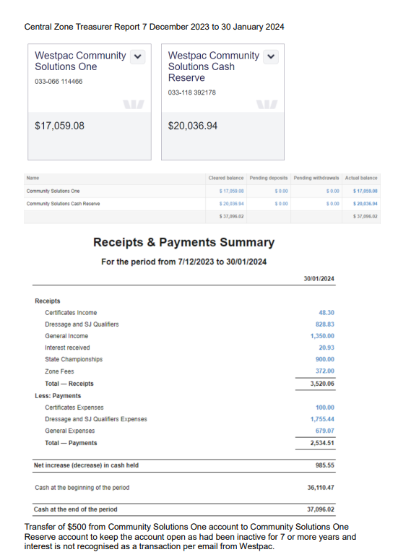
MOTION: Lisa |  |  |  |  | MOVED: |  | sECONDED:
Treasurer’s Report as tabled be noted and accepted. |  |  |  |  | Lisa |  | Niree

ITEM 3 |  |  | ZONE REPRESENTATIVE’S REPORT – Jo-anna Brennan  E-mail: jo.anna.brennan80@gmail.com
Central Zone Representative Report

February 2024

2024 State Showjumping and Dressage
- 24th & 25th February 2024 at Elmore
- Each zone needs to select a rider or riders to carry the zone flag or banner at the welcome parade at State SJ and Dressage on the Sat night. Strictly no dogs at all at. Elmore regardless of what Elmore’s rules are this is a PCV event SJ will be on grass. Advanced and level 1 dressage are indoor Grade 2,3,4 dressage all outdoors.
- Meaghan Sutherland will be acting CZ Rep for this weekend.
K.I Games Flat & Musical 2024
- 23rd & 24th June – venue TBC, however Bacchus Marsh have been approached.
- Discussion to use justgo, rather than manual entries
- The sub committee will meet in Feb 24 and further finalise programs and venues etc.
Games advised – Subject to change when program comes out
- Bending
- Carton race
- Two mug shuffle
- Two flag
- Lunch – 45 mins hour lunch break
- Stick pegging
- Baton relay
- Milk bottle
- Flag and drum
Games discussion about Miss K and PPNMG (Prince Phillip National Mounted Games)
- Simply that they are different events and that the committee remain different. One is a clinic style learning growing form and the other is simply and event each year
State Horse trials 2024
- Finley PC – 2nd weekend in May

CZ Programs and dates
- All programs and dates must be pre approved by the zone
- As per the email that was sent, with program guidelines and contacts.
- All to be sent to programs.centralzonepcav@gmail.com, some clubs still not doing this.
- As this is a 2nd request, going forward if not received to this email, they will not be responded to. For escalation if no response form the programs email send to centralzone.pcav@gmail.com

- G grade is coming in and grading guidelines are completed however not yet released Starting height 40cm no spreads

- Checked flag in TWZ time waste zone same colours as the grades but clearly shows the difference in course
Bit less bridle

- Next to the Mount name on card in brackets not bit less bridle There are more changes to this later and this may be that they have to do 2 rallies prior to comp in that bridle
Gear Rule – being missed at Gear Check
- 2.24.1 Saddlecloths A saddlecloth is mandatory when a saddle is used. A rider can use:
- A maximum of two saddlecloths Or
- One saddlecloth with or without a riser pad. Riser pad means any commercial riser and includes sheepskin half numnahs.

- A cool mesh pad/gel pad which goes against the horse’s skin can be used with either of the above options.
If two saddlecloths are used, the larger of the two (if applicable) must be put on first and the top saddle cloth must be visible all around the saddle.

- Hood – Rider After researching with CZ resources and other zone resources, via Bylaws and gear rules, we can not locate anything regarding “no hoodies”, the closest we have is the below, which also refers to the hood on a rain jacket.
• 1.32 Wet or cold weather:
- Permitted, subject to event organisers’ permission. Wet or cold weather gear should not have any loose flapping parts, including hoods, that could frighten a horse or snag on objects.
- Riders and parents: please approach the event organiser for permission to ride in wet or cold weather gear while competing.
- Competitor numbers and armbands, if required, must remain clearly visible at all times.
- Restrictions on logo sizes do not apply to wet or weather gear unless they are adopted as part of a Club’s official uniform.
Good Luck to all riders heading to the State SJ and Dressage!
Thanks Jo
 | ITEM 4 | ZONE CHIEF INSTRUCTOR REPORT – Meaghan Sutherland  E-mail: centralzone.ci@gmail.com
Hi Central Zone Clubs,

Welcome to the new membership year.

A couple of exciting developments for Central Zone Coaches over the Christmas period. With thanks to our Zone Rep Jo Brennan, the coaching grant that was due to run out in December 2023 is now extended to December 2024. As such as a club if you havent already put forward your 3 coaches for this grant please contact me via email, with the coaches name, email address and level of coaching. As per the grant, this assistance is available to 30 coaches within the zone. Or if your nominated coach has since not purchased there books and is no longer involved, please revise your nominations. Once coaches have been reimbursed we cant then change there nomination.

Central Zone ran our first Gear Check Accreditation in January and we are running our second on the 11th of February. This accreditation is free to all Central Zone members and it’s a great idea to get a couple of people from each club including coaches accredited. We are already 1 year in to our 2 year phase in of accredited gear checkers, so now is the time to get people qualified. The link for the upcoming event is; https://pca.justgo.com/Workbench/i/r/EventsAndBookings/details/80517C1537D812DFBA70E251EB39DE21154DEA1B

A reminder to all coaches that you need to register with Pony Club Victoria as a coach. To coach at a rally this is a pre requisite. If your are having issues registering please contact; coaching@ponyclubvic.org.au It is also a great idea once you have done this to register as a supporter at the club you predominantly coach at, so they can see your registration is current.

Pony Club Australia this week launched the new Level 1 Manual. What does this mean for coaches that have the old Level 1 Manual?? You have until the end of the year to complete the accreditation using the old manual. We do have a workshop planned for the first half of this year. If any Central Zone Club would like to nominate to host this weekend please contact me via email.

PCV are also offering webinars to coaches to assist with understanding requirements etc, keep your eye on the PCV Calendar on their website. The next one is the 30th January see this link to register. https://www.ponyclubvic.org.au/event/pca-coach-workbook-assistance-information-session/

I have also just created a Facebook group for Central Zone coaches; https://www.facebook.com/groups/1568144203952420 The aim of this group is to feed webinar/ training day/ important information to you, so please take the time to find the group and answer the simple question.

Think thats enough info for now, most importantly please make sure you are registered prior to coaching this year and we look forward to seeing you about the zone in the year to come. Please note I do work full time, so I may not respond immediately to your email, if however it has been a day or two, I will be 100% honest, I have probably forgotten to go back and respond or I’m still working out the answer!

Meaghan Sutherland
Central Zone Chief Instructor

 | item 5 |  |  | ZONE EXAMINING SECRETARY – Jayde Kirkham  E: Jayde.kirkham6@gmail.com PH: 0409002164
 |  |  |  | Whittlsesa hosting C certs in march 16/17 April

ITEM 6 |  | PRESIDENT’S REPORT ~ Niree Weybery  E: bernwey1@bigpond.com ph: 0408559915  Presidents Report – February 2024.  Happy New Year to all members.  A fair bit has happened since our last meeting.  • Dressage & SJ qualifiers  • Gear Check Accreditation Day  With lots more coming up in the next few weeks.  • State Games clinic at Woodlands  • State Dressage & SJ training weekend at Riddells Creek  • Gear Check course at Riddells Creek  • Gisborne & Glenlyon HT’s  And to finish off the month with the state Dressage & SJ championships – good luck to all our very talented riders who will be not only representing their clubs but our zone.  The 2024 International opportunities was emailed out to every member – I highly encourage any eligible rider / coach / manager to apply and experience what PCA has to offer.  The exec committee have been working tirelessly in recent months and I am very grateful for their enthusiasm and dedication to our zone.  Derek OLeary has been appointed ECO of PCV for the next 6 months.  Presidents Cup ~ new rules coming out in the next couple of weeks, just being reviewed by the Exec Committee. Will be out before the first PC. Event Secretary must be used to keep the scoring consistent.  Thank you and see you all soon.  Niree Weybury  0408559915
ITEM 7 | GENERAL BUSINESS WITH NOTICE

item 8 | GENERAL BUSINESS WITHOUT NOTICE
- Meghan Sutherland ~ 2nd gear check accred, 10-1.30 , free for all cz members. 11th February. Link is on just go. Next one will be 2nd half of the year.
Towards end of the year it will be compuslary to have accredited gear checkers for events and rallies. Already a rule for State events. 16 years and over.
- 24/02 macedon want to run an event clinic, programs have been sent for approval. Approval needs to come through to ensure the PCV rules are covered and everything covered under insurance.

Meeting Closed: 8.36 pm

April the 4th at Ross Watts Hall, New Gisborne.

