Central Zone of Pony Clubs Inc.

General Meeting of Central Zone on Thursday 4thApril 2024
Ross Watts Pavillion
New Gisborne
Meeting Opened: 8.11 pm
 | Zone Meetings for 2024
 | Thursday 1st February 2024 at New Gisborne Children’s Hall |  |  | Thursday 1st August 2024 online
 | Thursday 4th April 2024 2024 at New Gisborne Children’s Hall |  |  | AGM & Zone Meeting: Thursday 3rd October 2024 New Gisborne Hall
 | Thursday 6th June 2024 online |  |  | Thursday 5th December 2024 New Gisborne Children’s Hall
Central Zone Executive
Zone President: Niree Weybury (Woodlands) (apol)
Zone Vice President: Katrina McDougall (Gisborne)
Zone Vice President: J’Aimee Mallon (Riddells Creek)
Zone Secretary: Aimee Cuthbert (Werribee)
Zone Treasurer: Lisa Kennedy (Kyneton)
Zone Representative: Jo-anna Brennan (Woodlands)
Zone Exam Secretary: Jayde Kirkham (Macedon) (apol)
Zone Chief Instructor: Meaghan Sutherland (Riddells Creek)

Minutes: Aimee Cuthbert
Denotes Action Items.
Zone Delegates Present:
Member Club | Represented by: |  | Member Club | Represented by
Broadford | In Recess |  | Macedon | Olivia Greenwood
Bullengarook |  |  | Melton
Findon | Pam Kalms (apol) |  | Riddells Creek | Meagan Sutherland
Glenlyon | Sarah Klas  Kris Ford |  | Werribee | Wayne Cuthbert  Aimee Cuthbert
Gisborne | Leonie Lang  Katrina McDougall  Lisa Newman |  | Whittlesea | Naomi Slade
Heathcote |  |  | Williamstown | Emmy Lau  Trish Murphy
Kilmore |  |  | Woodend | Sharon Banner
Kyneton | Lisa Kennedy |  | Woodlands | Jo~Anna Brennan
Lancefield

Clubs not represented: Bullengarook. Heathcote, Kilmore, Melton, Lancefield

 |  |  | CONFIRMATION OF PREVIOUS MINUTES
 | Minutes of 1st February 2024 confirmed as a true and accurate record as amended.
 |  |  |  |  |  | Moved: Leonie lang |  | Seconded: LISA NEWMAN
 |  |  | BUSINESS ARISING FROM PREVIOUS MINUTES
President cup rules updated since last meeting by the Zone Executive. Update is attached to these minutes, and will be updated on the Zone platforms.

Changes are:
- Moved to the one calendar year
- Qualifier for sjump 1st or 2nd in pres cup series automatic into state sjump event
- 3rd and 4th spot from state qualifier event
- Fimister back to being the last event of the series
- In the rules it has to be offered all levels
- Can win pres cup consecutively at the same grade, but can go back to the zone rep and CI regarding rider grading
- Trying to encourage riders to go to the event and the series
- Some slight changes to scoring with big point gaps. Moved to more World Cup scoring.
- Hoping with state qualifier will get more riders back to showjumping and to the zone clubs.
- Hoping to make the final pres cup event to run quicker with scoring.
- Requested riders to make final day, but not a rule.
- Add a flier with the new rules and high light updated rules.
- Event sec recommended to score
- Also looking into Dressage series, watch this space.

 | ITEM 1 |  | CORRESPONDENCE
Inwards:
Whittlesea Pony Club 2024 ~ Dressage Day, Showjumping Day, Combined Training Day fliers.
Findon PC ~ donation to Central Zone
Glenlyon PC ~ request to add March clinic to CZ calendar.
Riddells Creek PC March Eventing Clinic
Bullengarook ~ request for Combined Training Day to be added to the calendar.
South Metro Zone Mini Mornington Horse Trials , CT and Supercross 2024
Melton PC new secretary
Gisborne PC Gear Check Motion
Findon PC ~ updated executive committee

Outwards:
Sally Macaulay, zone correspondence
Findon PC ~ donation to Central Zone
Central Zone Programs approval ~ add Bullengarook CT Day to calendar.
Melton PC new secretary

 | MOTION: |  |  |  | MOVED: |  | sECONDED:
 | Correspondence as tabled be noted and accepted.
 | ITEM 1 |  | BUSINESS ARISING FROM CORRESPONDENCE
ITEM 2 |  | TREASURER’S REPORT – Presented by Lisa Kennedy
inc
Central Zone Treasurer Report 1 February to 2 April 2024
Balances as at 2 April 2024 $41,882.20
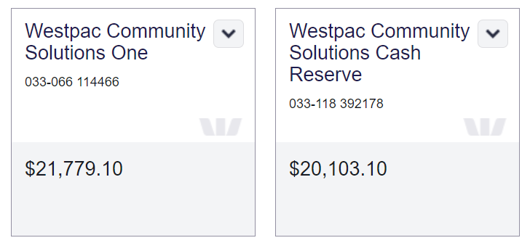
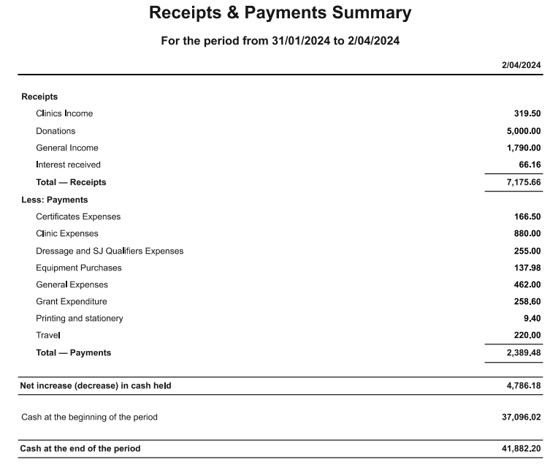
Findon Pony Club donation to Central Zone 29 February 2024 $5,000
Melton PC hosting fee for CZ Dressage qualifiers $255.00

MOTION: Lisa |  |  |  |  | MOVED: |  | sECONDED:
Treasurer’s Report as tabled be noted and accepted. |  |  |  |  | Meaghan |  | Jo

ITEM 3 |  |  | ZONE REPRESENTATIVE’S REPORT – Jo-anna Brennan  E-mail: jo.anna.brennan80@gmail.com
Central Zone Representative Report

Central Zone Representative Report
April 2024
• State Horse trials 2024
o Finley PC – 2nd weekend in May
o Qualifications to be signed off with forms – nothing finalised yet
• K.I Games Flat & Musical 2024
o 23rd & 24th June – Confirmed Bacchus Marsh
o Discussion to use justgo for state
o Games Sat and Flat Sunday – all rides on PCV website
Games - posted on PCV website
o Bending
o Carton race
o Two mug shuffle
o Two flag
o Lunch – 45 mins hour lunch break
o Stick pegging
o Baton relay
o Milk bottle
o Flag and drum
Closing date for State entry is 3rd June 2024
• The horse trials state register has been updated, this is for state use to show who has what XC courses across the state.
o After the meeting we have noted that no 110 course has been offered for 2 years, so CZ will propose that this needs to be reviewed and a 5 year plan put in place, whereby every 2 years a 110 course is offered, this has affected members that didn’t rejoin, PCA are loosing memberships. The XC register shows sufficient grounds across the state that can host.
• Rules Committee
o Dressage arena size for Grade 5,4 still with rules committee
o Final grading guidelines for G with rules committee
• Quiz
o Interzone Quiz challenge on again
▪ Zoom 20th May – Clinic
▪ Zoom 4th June round 1
▪ Zoom 19th July Round 2
▪ State Event onsite 27th July venue TBC
• Back protectors
o Please remind all riders that the back protector amnesty for the 2009 model ends 31-12- 24, therefore they need to ensure they have the correct one from 01-01-25. Ref to PCA gear rules
• New PCV Drug and Alcohol policy
o I was asked to draft a new policy for PCV to review with the board, as the current is 10 years old and out of date. While this is under review, please remember that you should not be riding under the influence of drugs or alcohol, remember you are a representative of your club, zone and country!
Good Luck to all riders heading to the State Horse Trials!
Thanks Jo

 | ITEM 4 | ZONE CHIEF INSTRUCTOR REPORT – Meaghan Sutherland  E-mail: centralzone.ci@gmail.com  CZ Chief Instructors Report – April 2024  2024 Dates of Interest  13th/ 14th April Higher Certificate Workshop @ Ballarat  27th/ 28th April Coaching Workshop and Assessment @ Riddells Creek Pony Club 13th/14th July Higher Certificate Workshop/ Assessment  C Certificate Assessment  5 Riders from 3 different clubs, Maya W Woodlands, Aella C, Chara C and Cooper O from Riddells Creek and Bridget Z Macedon, completed their C Certificates at the start of March, with thanks to assessor Aimee Cuthbert.  State Showjumping and Dressage Championships  Held at Elmore by Midland Zone, all of the Central Zone riders displayed amazing team comradely throughout the weekend. Marching behind the CZ banner, with flags made thanks to Kerr, the team was also the recipient of the most attendees at the Saturday night dinner, winning a set of rainbow showjump fills. The results only tell half the story of a long hot weekend. All riders looked after their ponies to the highest standard and all should be proud of their achievements over the weekend.  B grade Show Jumping Team 2nd overall  Chanel Radburn (Werribee PC) riding Bella (4th)  Alexah Robinson (Werribee PC) riding Isle of New Norfolk (5th) Amelia McDougall (Gisborne PC) riding Stoneleigh Sunday Rose Shanae Reid (Gisborne PC) riding Spark Up Trouble  C Grade Show Jumping Team 2nd overall  Sophie Fosnaugh (Gisborne PC ) riding Champagne Fizz (1st) Amelia McDougall (Gisborne PC) riding Kings Style (5th) Lili Taylor (Riddells Creek PC) riding Williams Dreaming  Alexah Robinson (Werribee PC) riding Harleys Blue Moonshine  D grade Show Jumping Team  Chloe O’Rourke (Riddells Creek PC) riding Atlas Abigail Fosnaugh (Gisborne PC) riding Vagabond  Angus Kerr (Woodlands PC) riding Tucker Providers Dream  Advanced Dressage (Individual):  Lili Taylor (Riddells Creek PC) riding Oscar – 1st overall Shanae Reid (Gisborne PC) riding Kalimna Barney – 4th overall  Grade 1 (Individual):  Audrey Berry (Werribee PC) riding Bellacre Tiggy Touchwood – 6th overall Darcey Macauley (Glenlyon PC) riding Parklands Faltango  Chanel Radburn (Werribee PC) riding Bella  Alice Berry (Werribee PC) riding Crestfields Jubilation  Grade 2 Team: 1st overall  Kloe Soper (Riddells Creek PC) riding Bonfire Belle – 1st Sophie Fosnaugh (Gisborne PC) riding Champagne Fizz - 6th Madeleine Manton (Woodend PC) riding Wyann Mercedes  (Res) Alexah Robinson (Werribee PC) riding Isle of New Norfolk – 5th  Grade 3 Team: 2nd overall  Tamsyn Harvey (Riddells Creek) riding Misty Night – 2nd Alexah Robinson (Werribee PC) riding Moonshine  Michelle Woodcroft (Riddells Creek) riding Strutin to a Tribute  Grade 4 (Individual); Composite team 2nd  Eva Potesta (Riddells Creek) riding Harry – 4th  Ruby Jones (Werribee PC) riding September Scarlett Rein  State and National Representatives  From Central Zone we had two coaches selected to coach the State Games Teams, congratulations to Junior Team Coach - Warwick Slade and Emerging Talent (Development) Squad Coach - Niree Weybury.  A massive congratulations to Hector Brennan (Woodlands) for being selected for the PCA Quiz team, for the tour of Kentucky USA in July.  Shetland Racing  Penny Mawhinney (Gisborne), Clara Greenwood (Macedon), were both selected as one of the 6 starts for the Shetland Race held at Moonee Valley. Arthur Mawhinney (Gisborne) also participated in the selection day held the day prior to the race. Penny Mawhinney took out the win by a short nose with Clara Greenwood coming 4th. All riders went through a training day held at Riddells Creek Pony Club, followed by a selection day on the Friday prior to the race. Congratulations to all involved.  Coaching Workshop  Thankyou to Woodend for trying to make this happen at there grounds unfortunately as the grounds were only available one day PCV requested a venue that was available both Sat and Sun. As such Riddells Creek will host the training and update day on the Saturday, including the PCA Club Empowerment Program and the assessment day on the Sunday. Register via JustGo.  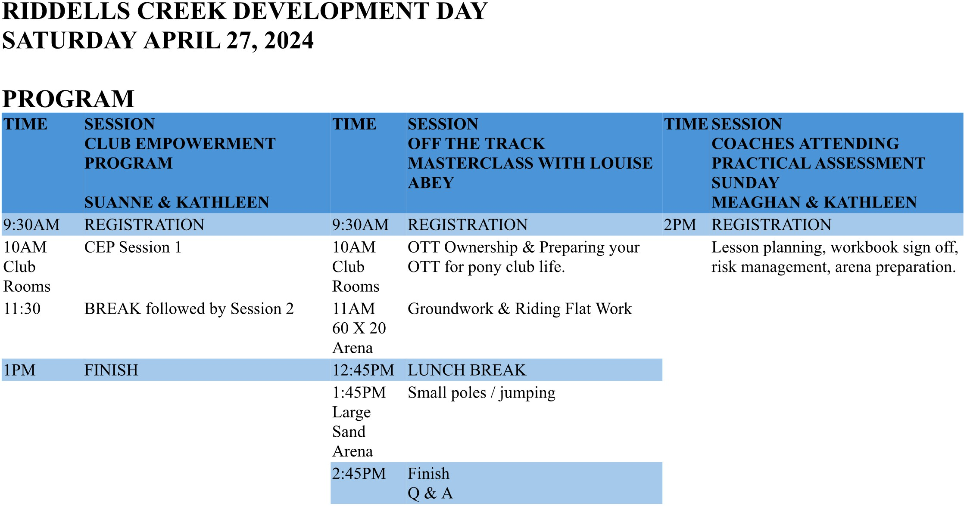  COMPETITION TIME!  The Zone Chief Instructors Panel (CIP) have initiated a new competition for members. Clubs are invited to create a poster or model of a horse, about a metre high, with at least 40 parts of the horse labelled on it. This may include an interactive component or be a permanently labelled item.  The model or poster is deigned to be a fixture in your Pony Club home building, to teach future generations of members the parts of the horse.  To enter, simply head to our website and read the terms and conditions. Get to work on your club creation between now and the end of April. Then submit your creation via photos, video or a link by using the online entry form found on our website.  Great club prizes on offer with thanks to our major sponsor Horseland.  All the best for the upcoming months, Meaghan Sutherland  CZCI
Meaghan Sutherland
Central Zone Chief Instructor

 | item 5 |  |  | ZONE EXAMINING SECRETARY – Jayde Kirkham  E: Jayde.kirkham6@gmail.com PH: 0409002164

ZES Report April 2024
Jayde Kirkham E: Jayde.kirkham6@gmail.com
PH: 0409 002 164
Hi everyone!

C Certificate
Assessment Day Saturday 16th March 2024 – Riddells Creek Pony Club
The last C certificate assessment day was held at Riddells Creek PC on the 16th March. Thank you to Riddells Creek for hosting a well-run day (as always!) and to Aimee Cuthbert for assessing the candidates.
All candidates were successful and the day ran very smoothly – well done!
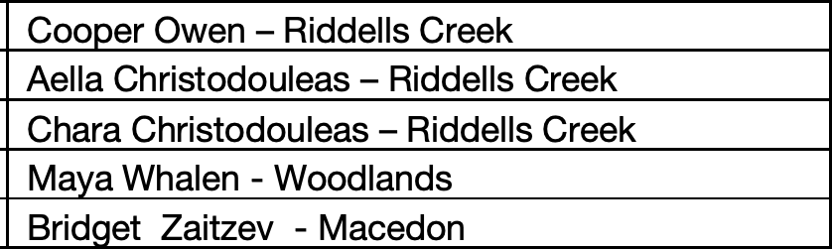

Spring C Assessment
19th October 2024 - Please put these dates in your calendar!!
If clubs could please let me know how many candidates they have for this assessment as soon as possible that would be great (makes booking in our fabulous assessors much easier!).

Although Riddells Creek are great hosts (have hosted the last 2 in a row!) it would be great to get some other clubs involved too – so please let me know if your club would be interested in hosting!

Other important certificate dates:
13th/14th July – Higher Certificates Workshop/ Assessment (See Meghan Sutherland for details)

REMINDERS:
- Both D and D* certificates are now a prerequisite for the C certificate.
- Riders must ride a qualified horse for the assessment – e.g. have attended 2 rallies Thanks ☺
Jayde Kirkham

ITEM 6 |  | PRESIDENT’S REPORT ~ Niree Weybery  E: bernwey1@bigpond.com ph: 0408559915  Niree Weybury  0408559915
ITEM 7 | GENERAL BUSINESS WITH NOTICE
- Please refer to page 3 motion below from Gisborne Pony Club, regarding Gear Check.
- Findon PC donation to CZ
- Williamstown PC interested in hosting a gear check accreditation for the 2nd half of the year

Motion from From Gisborne Pony Club RE: GEAR CHECK

Discussion points for gear check submission from Gisborne PC Committee.
As understood the purposes of competition gear checks are to:
- Ensure safety of equipment used on horses.
- Ensure comfort for the horse/pony for equipment used on horses.
- Attempt to ensure competition rules are complied with for fairness of competition.
- Loosely as an education tool

- Anecdotal evidence is that there are extremely low to no safety issues picked up during competition gear checks.
  - The standard of gear has increased significantly over the years removing the original aim of picking up ‘rotten stitching on stirrup leathers, cracked leather and breaking girth points etc.’ These concerns no longer apply.
- It is widely acknowledged that volunteerism is a significant issue that is anticipated to continue to get worse. Sourcing gear checkers on the competition days is already difficult and projected to become even more difficult when/if gear checkers will be required to be accredited. The ongoing sourcing of gear checkers is perceived as unsustainable.
- It is a source of significant angst among competitors on competition days.
  - Volunteer gear checkers providing wrong information or missing genuine items of concern.
  - Research data from PCV council (several years ago) has shown that it is a source of significant negative perception for the organization.
The request is that Central Zone make a formal request for PCV to genuinely investigate the cost/benefit in relation to the genuine sustainability for gear check and gear checkers. Some issues requested to be addressed are:
- Provide some genuine data to understand if Competition gear checks are achieving the aims of improving comfort and safety.
- Understand if the ‘gear check’ objective to adhere to competition rules is valid given the burden still falls with the competitor or judges.
- Establish if there are better ways of achieving any education objectives. (e.g. demonstrate gear requirements as part of the grading process)
This request is made with genuine concern for the sustainability of the gear check process. We feel that it is a significant issue that warrants investigation so that informed decisions and discussion can be made using real world data.
In the light of these arguments, Gisborne PC would like to submit the following motion for the next CZ meeting agenda:
“That the PCV State Council investigate the cost/benefit in relation to the genuine sustainability for gear check and gear checkers at competitions. Some issues requested to be addressed are:
- Provide some quantitative data to demonstrate if Competition gear checks are achieving the aims of improving comfort and safety.
- Consider if the ‘gear check’ objective to adhere to competition rules is valid given the burden still falls with the competitor or judges.
- Establish if there are better ways of achieving any education objectives. (e.g. demonstrate gear requirements as part of the grading process)”

Outcome from discussion of the above:

- Q: How would open sections be managed? Open not part of the PC grading system
A: Open should know the rules and EV/FEI can still check
- Still clearly stated its on the onus of the rider, but someone not accredited could have the wrong information.
- General feeling that people are feeling pressured into gear checking at competition level.
- Ask THERESA MATTHEWS if she has kept records of gear check at events.
- Suggested zone to create a zone gear check data sheet for completions only.
- Should it be added more into certificate work?
- How to police open riders?
- Suggested to pay Bronwyn Fyfe to do some gear checking info at rallies
- Contact Gear check accreditors to use as a resource pool and pay at events and wants to do it.
- Suggested event and rally cheat sheet
- Guidelines from PCA WHAT SHOULD be covered at an event.
- Ask Event Sec if they have notes on Gear Check .
- Where clubs use Event Secretary please add in a note box to help collect this data

Suggesting to hold the movement and discuss further.
- Get more zone comp data to record at events to achieve these aims. Send a 1 page sheet to advise on events gear check. What was not in rules / what is safety. Comfort and safety vs Rules.
- Send an accredited person to clubs and educate with zone support financially.

Aim to have data by the 2024 CENTRAL ZONE AGM

item 8 | GENERAL BUSINESS WITHOUT NOTICE

Meeting Closed: 10.08 PM

THURSDAY JUNE 6TH ONLINE VIA ZOOM

