Central Zone of Pony Clubs Inc.

General Meeting of Central Zone on Thursday 6th June
ONLINE VIA ZOOM
Meeting Opened: 8.03pm
 | Zone Meetings for 2024
 | Thursday 1st February 2024 at New Gisborne Children’s Hall |  |  | Thursday 1st August 2024 online
 | Thursday 4th April 2024 2024 at New Gisborne Children’s Hall |  |  | AGM & Zone Meeting: Thursday 3rd October 2024 New Gisborne Hall
 | Thursday 6th June 2024 online |  |  | Thursday 5th December 2024 New Gisborne Children’s Hall
Central Zone Executive
Zone President: Niree Weybury (Woodlands)
Zone Vice President: Katrina McDougall (Gisborne)
Zone Vice President: J’Aimee Mallon (Riddells Creek) (Apol)
Zone Secretary: Aimee Cuthbert (Werribee) (Apol)
Zone Treasurer: Lisa Kennedy (Kyneton)
Zone Representative: Jo-anna Brennan (Woodlands)
Zone Exam Secretary: Jayde Kirkham (Macedon) (Apol)
Zone Chief Instructor: Meaghan Sutherland (Riddells Creek)

Minutes:
Denotes Action Items.
Zone Delegates Present:
Member Club | Represented by: |  | Member Club | Represented by
Broadford | In Recess |  | Macedon | Terri Kirkham/Olivia Greenwood
Bullengarook | None |  | Melton | None
Findon | Pam Kalms (Apol)  Brendan |  | Riddells Creek | Meaghan Sutherland  J’aime Mallon (Apol)
Glenlyon | Sally Macaulay/Sarah Klas |  | Werribee | Aimee Cuthbert (Apol)  Wayne Cuthbert
Gisborne | Leonie Lang/Katrina McDougall |  | Whittlesea | Naomi Slade/Carly Delany
Heathcote |  |  | Williamstown | Trish Murphy
Kilmore | Tanya Christie |  | Woodend | Sharon Banner
Kyneton | Cassandra Waters/Lisa Kennedy |  | Woodlands | Jo Brennan/N Weybury
Lancefield | Emma Altas

Clubs not represented:

 |  |  | CONFIRMATION OF PREVIOUS MINUTES
 | Minutes of April 2024 confirmed as a true and accurate record as amended.
 |  |  |  |  |  | Moved: Lisa Kennedy |  | Seconded: Emma Altas
 |  |  | BUSINESS ARISING FROM PREVIOUS MINUTES
 | ITEM 1 |  | CORRESPONDENCE
Inwards:
Lancefield PC Combined Training Day flier approval
Melton PC advised no Showjumping event & car boot sale 21st April.
Riddell’s Creek PC Eventing Clinic, May 4th
Heathcote PC 2024 Calendar events
Melton District PC ~ offering to host the October C certs
Grading Query regarding Grading of riders
Williamstown PC Gear Check Accreditation workshop
Kyneton PC updated Executive roles and Event Dates 2025.
Glenlyon PC offer to host the Lowden Shield 2024
Glenlyon PC zone records register.
Kilmore PC new saddle blanket

Outwards:
Central Zone Games, Flat Musical entry from 2024
From Zone CI to all DC’s nominated on Just Go regarding Grading Guidelines and requirements
Kyneton PC event dates 2025.
Glenlyon PC offer to host the Lowden Shield 2024
Grading Query regarding Grading of riders
C certificate assessment day, October 2024
Kilmore PC new saddle blanket

 | MOTION: |  |  |  | MOVED: |  | sECONDED:
 | Correspondence as tabled be noted and accepted. |  |  |  | Trish Murphy |  | Leonie Lang
 | ITEM 1 |  | BUSINESS ARISING FROM CORRESPONDENCE
 | N.A
ITEM 2 |  | TREASURER’S REPORT – Presented by Lisa Kennedy
Cash 1 account $22,100,85 Cash 2 account $20,150.70
GFM Inc - $2520.00
GFM Exp $1635.50
Profit $864.50
Payment for state entrys go out next week.
Waiver forms need to be signed by all State riders

CZ Treasurer Report 3 April 2024 to 3 June 2024
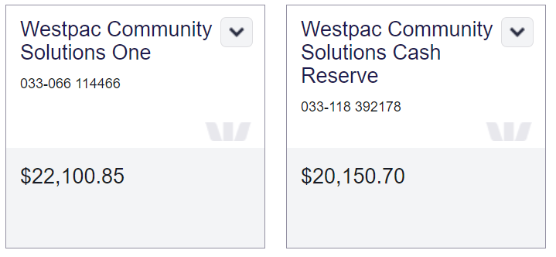
Balance at 3 June 2024 $42,251.55

Games, Flat & Musical income $2,520.00, expenses $1,635.50 – profit $864.50

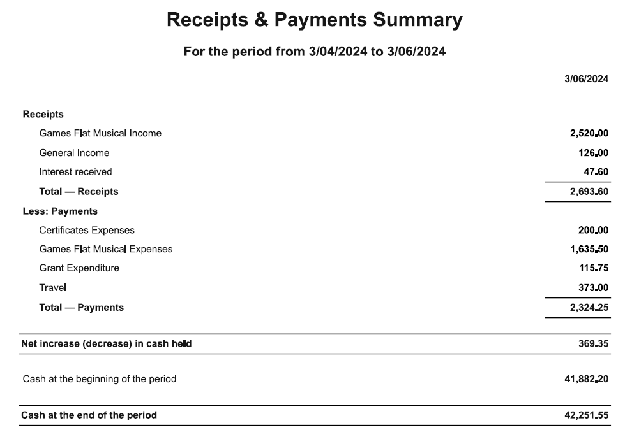

All reports moved by |  |  |  |  | MOVED: Cassandra Waters |  | sECONDED: Wayne Cuthbert
Treasurer’s Report as tabled be noted and accepted.

ITEM 3 |  |  | ZONE REPRESENTATIVE’S REPORT – Jo-anna Brennan  E-mail: jo.anna.brennan80@gmail.com
As attached.

 | ITEM 4 | ZONE CHIEF INSTRUCTOR REPORT – Meaghan Sutherland  E-mail: centralzone.ci@gmail.com
As attached

Meaghan Sutherland
Central Zone Chief Instructor

 | item 5 |  |  | ZONE EXAMINING SECRETARY – Jayde Kirkham  E: Jayde.kirkham6@gmail.com PH: 0409002164

ZES Report June 2024*
Jayde Kirkham E: Jayde.kirkham6@gmail.com
PH: 0409 002 164
*Melton PC have emailed centralzone.pcav@gmail.com offering to host the October C certs. Can them email please be re forwarded again to the above email again please.

ITEM 6 |  | PRESIDENT’S REPORT ~ Niree Weybery  E: bernwey1@bigpond.com ph: 0408559915  Great committee and everyone is working really hard and a great committee  Reminded everyone to go via zone before PCV  Games, Flat Musical – If anyone wants help with any of these elements please contact zone, we can help find coaches and training days and more than happy to help in anyway we can.  Niree Weybury  0408559915
item 7 |  | GENERAL BUSINESS WITH NOTICE  7.1 Kilmore & District Pony Club Saddle Blanket required approval.  Approved Lisa Kennedy and Jo Brennan  Dark brown quilted all purpose pad with matching brown girth keeper.  Yellow rope with dark brown binding.  Yellow embroidered name “Kilmore” in the corner on near side (Font TBC).Club have advised the text is within PCV standards.  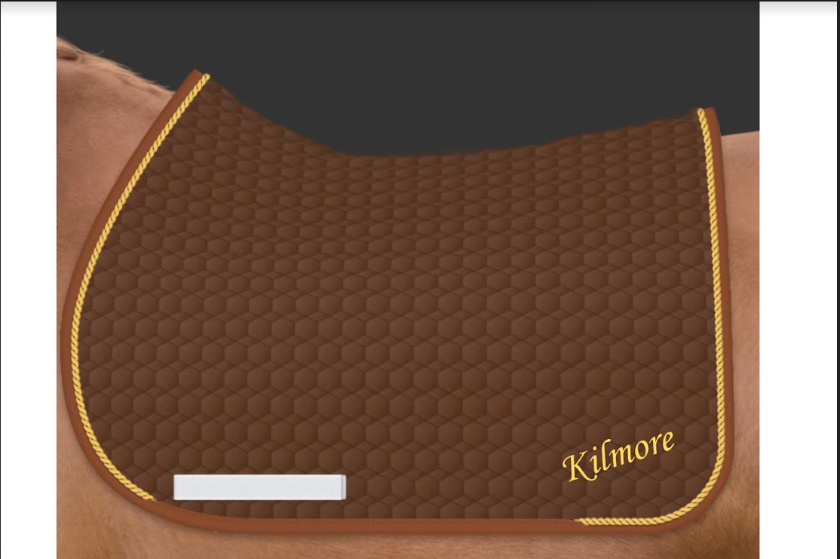  7.2 Central Zone FB page and Website.  FB: https://www.facebook.com/profile.php?id=100064402431301  Website : https://centralzonevic.com/  Just a reminder the Zone has a FB and Website, with links to the Zone Calendars, Zone Executive contacts and roles, Newsletter, etc. There is lots of information to be found on these pages, and can provide general information, or who is the best contact for a query.  On the FB you will also find a FEATURED tab. This is where important information is stored for Clubs to find information quickly, including the link to the current Zone Calendar, JUST GO administrator details, Hosting an Event information page, Zone Exec panel, and upcoming events.  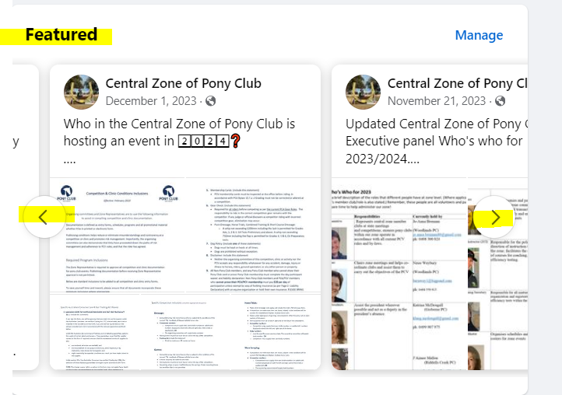
Item 8 | GENERAL BUSINESS WITHOUT NOTICE
- Trish Murphy (Williamstown) – Borrowed electronic timer last time and it wasn’t working, leg is broken an it hasn’t been fixed. Terri Kirkham (Macedon) has the gear and it works, but it is broken.
Terri will assit Williamstown on how to work the timing gear. Leg is confirmed broken
- Request for Presidents cup rules to be emailed out to all clubs. Leonie confirmed they are on the website. – Agreed they will be emailed.
- Kilmore wanted to check if any rider pre grade 6 on leads could do a SJ course at their CTday, however it’s a no. Confirmed by Niree Weybury and Meg Sutherland
Naomi Slade – Whittlesea Pony Club asked if a grid block is used and not a wing, can the rider on a lead go over the jump and not the handler. Meg confirmed that a led rider can not go over anything that is off the ground.
- Terri Kirkham - Macedon requested that someone review F Grade riders for Presidents Cup, as they were not suitable and need to be checked.
- PPNMG Paris and Teams Comp at end of June… Get entering!! (NW)
- NW - draft an email re assisting in grading, education of parents more than anything. The pressure on clubs to grade even though a child is not ready. Zone to assit to educate!
Please find the PCV rules regarding the Leadline Riders:
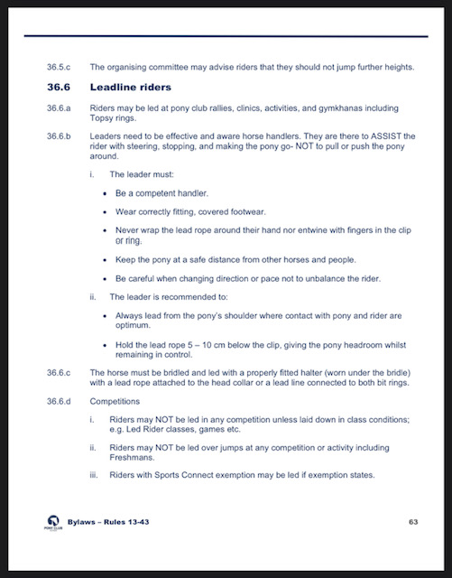

Meeting Closed: 8.42pm
THURSDAY August 1st 8.00pm - ZOOM

