Central Zone of Pony Clubs Inc.

General Meeting of Central Zone on Thursday 6th February 2025
Ross Watts Pavillion
New Gisborne
Meeting Opened: 8.05 pm
 | Zone Meetings for 2025
 | Thursday 6Th February at New Gisborne Children’s Hall |  |  | Thursday 7th August 2025 online
 | Thursday 3rd April 2025 at online |  |  | AGM & Zone Meeting: Thursday 9th October 2025 New Gisborne Hall
 | Thursday 5th June 2025 online |  |  | Thursday 4th December 2025 New Gisborne Children’s Hall
Central Zone Executive
Zone President: Niree Weybury (Woodlands)
Zone Vice President: Katrina McDougall (Gisborne)
Zone Vice President: Madeline Manton (Woodend)
Zone Secretary: Aimee Cuthbert (Werribee)
Zone Treasurer: Lisa Kennedy (Kyneton)
Zone Representative: Jo-anna Brennan (Woodlands)
Zone Exam Secretary: Jayde Kirkham (Macedon)
Zone Chief Instructor: Meaghan Sutherland (Riddells Creek)

Minutes: Aimee Cuthbert
Denotes Action Items.
Zone Delegates Present:
Member Club | Represented by: |  | Member Club | Represented by
Broadford |  |  | Macedon | Olivia Green (Apol)  Peter Wall  Teri Kirkham
Bullengarook |  |  | Melton
Findon | Fernando (apol)  Pam Kalms |  | Riddells Creek | Davina Taylor (apol)  Meaghan Sutherland
Glenlyon | Kris Ford  Sarah Klas |  | Werribee | Wayne Cuthbert  Aimee Cuthbert
Gisborne | Katrina McDougall (Apol)  Leonie Lang |  | Whittlesea | Naomi Slade  Jess Hams
Heathcote |  |  | Williamstown | Ann Ryan (Apol)  Trish Murphy (Apol)
Kilmore | Apology |  | Woodend | Madeline Manton  Sharon Banner
Kyneton | Lisa Kennedy  Cassandra Water |  | Woodlands | Sarah Kerr (apol)  Jo Brennan  Dan Foster  Niree Weybury
Lancefield | Emma Atlas |  | ZES | Jayde Kirkham

Clubs not represented:

 |  |  | CONFIRMATION OF PREVIOUS MINUTES
Minutes of PREVIOUS MEETING as a true and accurate record as amended.

Amended to be made last minutes.

 |  |  |  |  |  | Moved: |  | Seconded:
 |  |  | BUSINESS ARISING FROM PREVIOUS MINUTES
 | ITEM 1 |  | CORRESPONDENCE
Reminder again about the CZ PROGRAMS email address.

Inwards:
2024 National & International funding riders
Melton PC Christmas rally photos
Bullengarook calendar request
Leonie Lang, Updated CZ calendar
Williamstown PC Meeting apologies
RCPC February Eventing Clinic 2025
Glenlyon PC HT approval 2025
2024 National & International funding riders forms
Lancefield 2025 calendar dates

Outwards:
2024 National & International funding riders forms
Melton PC Christmas rally photos to Leonie for the Newsletter.
Ross Watts Hall contacts with meeting dates for 2025
Removal of previous members from the Central Zone mailing list

 | MOTION: |  |  |  | MOVED:Niree |  | sECONDED: maddi
 | Correspondence as tabled be noted and accepted. Deferred to next meeting.
 | ITEM 1 |  | BUSINESS ARISING FROM CORRESPONDENCE
ITEM 2 |  | TREASURER’S REPORT – Presented by Lisa Kennedy
inc
As tabled See Appendix 1

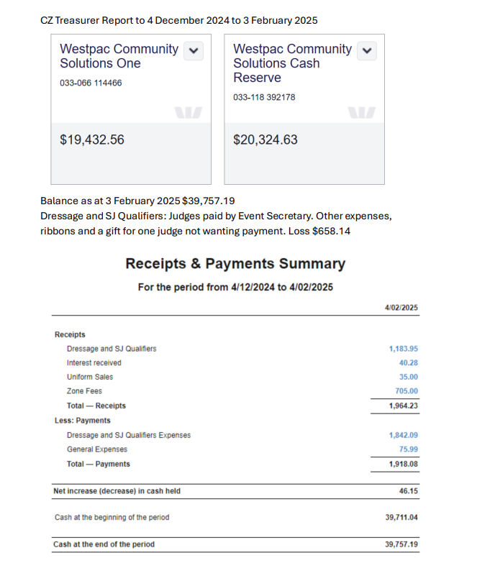

MOTION: Lisa |  |  |  |  | MOVED: |  | sECONDED:
Treasurer’s Report as tabled be noted and accepted. |  |  |  |  | Lisa |  | Niree

ITEM 3 |  |  | ZONE REPRESENTATIVE’S REPORT – Jo-anna Brennan  E-mail: jo.anna.brennan80@gmail.com
Central Zone Representative Report
https://www.ponyclubvic.org.au/education/

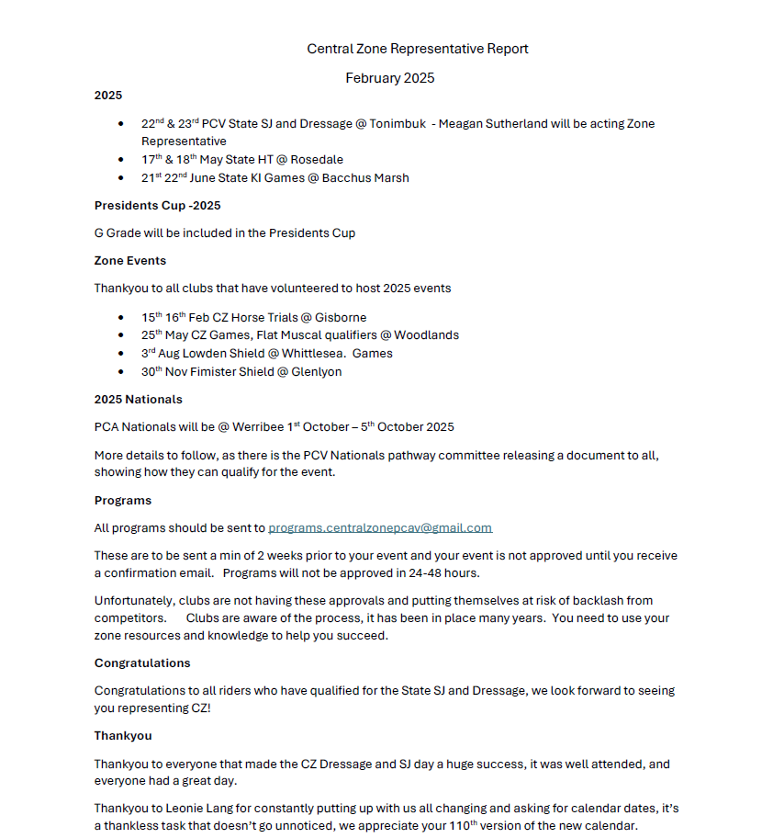
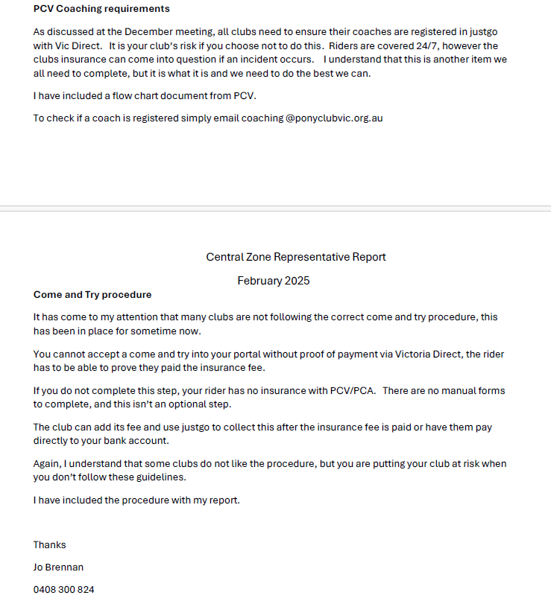

 | ITEM 4 | ZONE CHIEF INSTRUCTOR REPORT – Meaghan Sutherland  E-mail: centralzone.ci@gmail.com
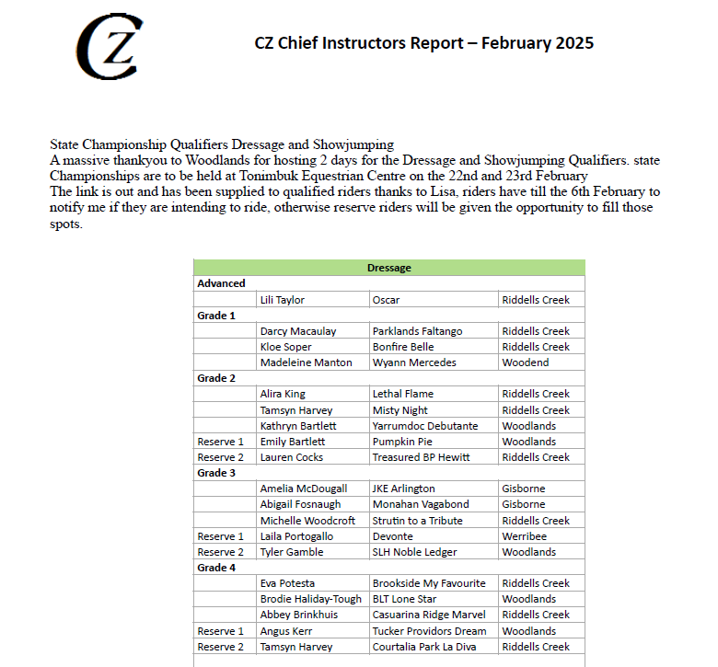

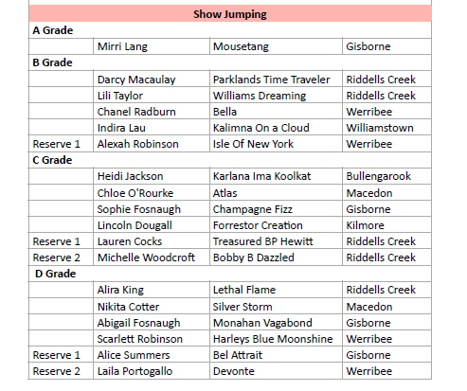

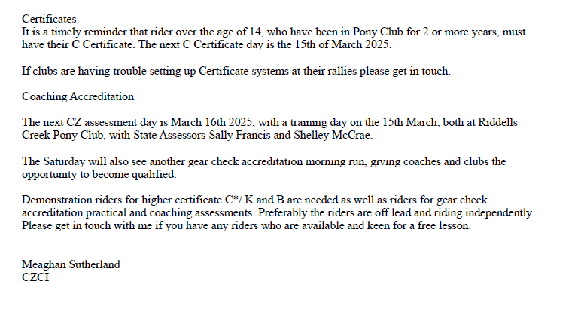
 | item 5 |  |  | ZONE EXAMINING SECRETARY – Jayde Kirkham  E: Jayde.kirkham6@gmail.com PH: 0409002164
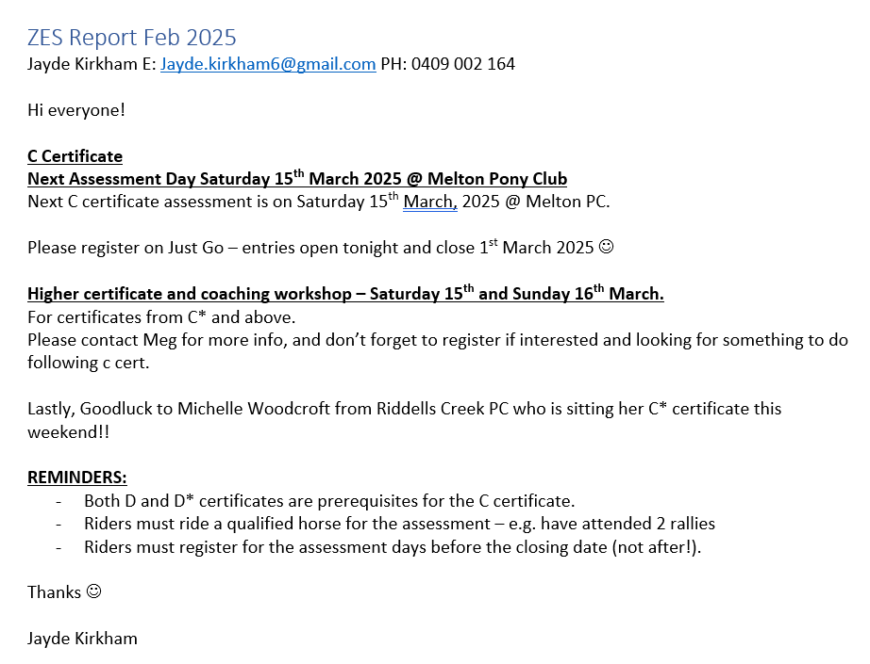

- Findon PC advised that Juliette Payne has changed clubs & zones and still needs to finalise her C cert. Pam and Jayde working on this completed.

ITEM 6 |  | PRESIDENT’S REPORT ~ Niree Weybery  E: bernwey1@bigpond.com ph: 0408559915  First State event for the year was the Dressage and Showjumping. Thanks to everyone that pitched in for the event this year ! It was spread out over 2 days and it was hot, but just a reminder that everyone needs to offer assistance at these events. There as some great talent and some riders outstanding at the event! Well done to everyone.  The next Gear Checking assessment day is being hosted by the SOUTH METRO ZONE which will be on February 16th. And the next C Cert day for our zone is March 15th at Melton.  Jo & myself are working on the PPMG games training and will be hosting doing 5 games clinics this year if anyone would like to come and watch or ride ~ can be non competitive kids. The entries are Shut on JUST GO but pop a messge in ifyou would still like to join in,  Next one Maryborough march 16  Niree Weybury  0408559915
ITEM 7 | GENERAL BUSINESS WITH NOTICE
*Ride To Time
Jo B advised we need to re~engange the RIDE TO TIME and need some one to take it on. It would ne good to have it back as it has been a popular discipline in the zone.
Meaghan S went to the RTT training day last year, and advised clubs can buy training clickers on TEMU for $30 for 10. The clickers helps the riders get their time over each 100 metres.
For riders to compete at RTT ~ they MUST have a – Breastplate / AP or JUMP Saddle / Back protector as they are riding on a racetrack.
Riders go out one at a time and learn to count the timing and ride at a given pace ~ its not about being the fastest!
Grading is MAIDEN and OPEN , and any PCV member doing track work cannot ride at MAIDEN level.
To practice at rallies, clubs can measure out a 100 meter track at a rally and work the riders times on this.

*Just GO
It has been found that removal of former members from portal who have been receiving PCA/PCV/Zone updates via email. Please remove excess members from your portal to ensure they are no longer on the system in the background.

* 2025 Central Zone HT & Mathew Slade Memorial trophy
This will be ingergrated into the GISBORNE PC Horse Trials for 2025!

* Glenlyon PC HT gear check
GPC require an accredited gear checker for the their 2025 Horse Trials. Financial details discussed for someone to cover this role. The club has accredited gear checkers in their club, but they are required for other roles at the event.

item 8 | GENERAL BUSINESS WITHOUT NOTICE
- The CZ Showjumping Trailer will now be stored at RCPC Grounds as the Macedon PC grounds are located in a hi fire area.

- Meaghan advised for gear check proposes, that the FEI tapperd nose gages would be purchased for each CZ. Only 1 only per club ~ if its lost it will not be replaced. To collect and have ready for next meeting.

- KAY IRVING Flat / Musical / Games / Pairs will be held on MAY 25. There will be composite & assisted musical teams, and hosted by Woodlands PC.

- Fundraiser for WORLDS GAMES! Riders from WOODLANDS PC have made WORLD GAMES, and are hosting fundraisers to assist getting them there. There will be a fundraiser comp at WOODLANDS PC grounds Saturday 30TH March, working on Kay irving indivial races in the morning and the afternoon would be team comps. It can be a good way to practice and introduce riders to the races. $45 per rider, lead line on the day, and teams can use this as a practice day. All state coaches there on the day also to assist riders!

- NATIONALS 2025 is OCTOBER 1-ST-5TH at Werirbee Park National Equestrian Centre. The October ZONE meeting and AGM will be moved to Thursday 9th October. Documents will be coming out soon about nationals riders and how to qualify / enter for 2025. The BASE level is riders will need a C cert. Full Natioanals will be held at WPNEC, and no off site hubs. The Interpacific Pony Club exchange riders which is ~ Hong Kong , USA, Canada, New Zealand, and Australia ~ guessing may be held with nationals this years?? 2 years ago it was in NZ over 21 days. Disciplines are shuffled and there may be Combined Training with this years event? Recommend the Event riders try for this in the CT section if held this year. The rest of the competition is Showjumping where riders are on borrowed horses. Candites must have their B certs.

Meeting Closed: 9.24 PM

Next meeting: Thursday 3rd April , moved to online

