Central Zone of Pony Clubs Inc.

General Meeting of Central Zone on Thursday 9th October 2025

Meeting Opened: 8.36pm
 | Zone Meetings for 2025
 | Thursday 6Th February at New Gisborne Children’s Hall |  |  | Thursday 7th August 2025 online
 | Thursday 3rd April 2025 online |  |  | AGM & Zone Meeting: Thursday 9th October 2025 New Gisborne Hall
 | Thursday 5th June 2025 online |  |  | Thursday 4th December 2025 New Gisborne Children’s Hall
Central Zone Executive
Zone President: Niree Weybury (Woodlands)
Zone Vice President: Katrina McDougall (Gisborne)
Zone Vice President: Madeline Manton (Woodend)
Zone Secretary: Aimee Cuthbert (Werribee) APOL
Zone Treasurer: Lisa Kennedy (Kyneton)
Zone Representative: Jo-anna Brennan (Woodlands)
Zone Exam Secretary: Jayde Kirkham (Macedon) APOL
Zone Chief Instructor: Meaghan Sutherland (Riddells Creek)

Minutes:
Denotes Action Items.
Zone Delegates Present:
Member Club | Represented by: |  | Member Club | Represented by
Broadford | In Recess |  | Macedon | Teri Kirkham  Olivia Greenwood APOL
Bullengarook | Lisa Commandeur |  | Melton | Elizabeth Robertson (APOL)
Findon | Pam Kalms  Ines Santos Mattos |  | Riddells Creek | Meaghan Sutherland  Lauren Cocks  Carol Anderson
Glenlyon | Kris Ford  Sarah Klas |  | Werribee | Aimee Cuthbert (Apology)  Wayne Cuthbert
Gisborne | Daniel Craig  Leonie Lang |  | Whittlesea | Naomi Slade
Heathcote | Sarah Wilkins APOL |  | Williamstown | Trish Murphy
Kilmore | Deb Dougall APOL |  | Woodend | Sharon Banner  Madeleine Manton
Kyneton | Lisa Kennedy  Cassandra Waters |  | Woodlands | Jo Brennan  Niree Weybury
Lancefield |  |  | CZ ZES | Jayde Kirkham APOL

 |  |  | CONFIRMATION OF PREVIOUS MINUTES
Minutes of PREVIOUS MEETING as a true and accurate record as amended.
Attendee; Olivia Greenwood

Amended to be made last minutes.

 |  |  |  |  |  | Moved: Leonie Lang |  | Seconded: Naomi slade
 |  |  | BUSINESCS ARISING FROM PREVIOUS MINUTES
 | - Circulation of James presentation??? Being edited for circulation
 | p
 | ITEM 1 |  | CORRESPONDENCE
Inwards:
- Pony Club Classes - Daylesford Agricultural Show 22nd November 2025
- Kilmore Pony Club is an apology for the AGM
- Central Zone Presidents and DCs for 25/26 Information sheet
- Gear Checker Accreditation assessment question
- New DC for Melton District PC
- WWCC clearance
- Presidents Cup progressive score
- Feedback from Melton PC regarding F & G GRADE SHOWJUMPING OPTIMUM TIME
- Meeting apologies, Heathcote & Macedon

Outwards:
- Meeting apologies
- Gear Checker Accreditation assessment question
- New DC for Melton District PC
- Presidents Cup Progressive score

 | MOTION: |  |  |  | MOVED: |  | sECONDED:
 | Correspondence as tabled be noted and accepted. Deferred to next meeting.
 | ITEM 1 |  | BUSINESS ARISING FROM CORRESPONDENCE
ITEM 2 |  | TREASURER’S REPORT – Presented by Lisa Kennedy
inc
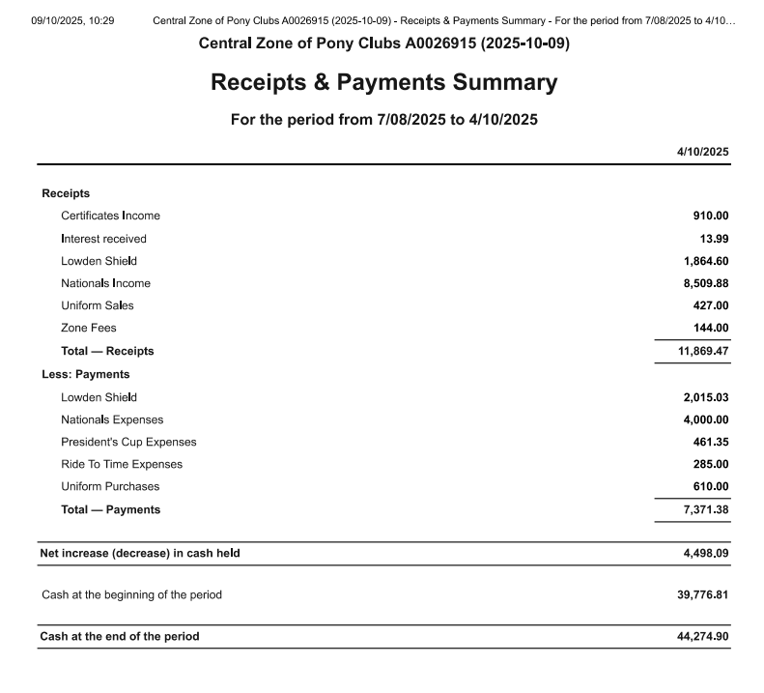

MOTION: Lisa |  |  |  |  | MOVED: |  | sECONDED:
Treasurer’s Report as tabled be noted and accepted. |  |  |  |  | Lisa Kenedy |  | Niree Weybury

ITEM 3 |  |  | ZONE REPRESENTATIVE’S REPORT – Jo-anna Brennan  E-mail: jo.anna.brennan80@gmail.com
Central Zone Representative Report

 | ITEM 4 | ZONE CHIEF INSTRUCTOR REPORT – Meaghan Sutherland  E-mail: centralzone.ci@gmail.com
- Was great to have a number of Presidents and DCs attend ther CZ information afternoon/ evening, enabling discussion regarding rules etc
- Looking to have a CZ information session on Just Go
- Looking to have CZ information session on running events, once the 2026 has been finalised
- Massive congratulations to our International and National Representatives in the last month, Niree Weybury and Dan Foster took part in the Mounted Games Exchange in the UK, whilst lili Taylor and J’Aime Mallon took part in the Interpacific Exchange in Victoria
- Congratulations to all our riders who competed in the Nationals at Werribee, a number of these riders and there parents also did a bit of fundraising through the hosting of the welcome BBQ. We had amazingly 20 riders at the PCA National Championships, 19 riders attended. Our riders rode so well and within the zone we have a number of National Champions and so many riders who rode above there level.
- Special mention and thankyou to Wayne Cuthbert for his efforts in ensuring the Horse Trials section of Nationals ran
- Looking in the new year to host a couple of Higher Certificate workshops/ a coach assessment training and assessment day and role out a changed format of gear check accreditation
- This year will also see a new format for club visits across the zone with a pre visit Jot Form/ survey to be sent out
 | item 5 |  |  | ZONE EXAMINING SECRETARY – Jayde Kirkham  E: Jayde.kirkham6@gmail.com PH: 0409002164
 |  |  |  | Not presented

ITEM 6
ITEM 7 | GENERAL BUSINESS WITH NOTICE
- Melton District Pony Club, F & G GRADE SHOWJUMPING OPTIMUM TIME: Club Feedback
As requested, this topic (along with screenshots of James's presentation) was presented to our members and the following is the feedback we received. There was feedback in favour and against the current Optimum Time rules.

Feedback from members...
- My honest opinion is that the optimum time for F grade is fantastic as this height children are still learning. Before the optimum time my daughter could never win a ribbon on her pony as all the kids were going so fast around this course (and my honest opinion was they should be up in the E grade as there were too good for F grade) once the optimum time rule came in my daughter actually had a chance at winning ribbons. The time is a bit slow now for her though she can still do a bit of canter in between trotting and it has given her so much confidence as she doesn’t have to race around the course, she can take her time and have fun. She is nearly ready now to go up to E grade and then she can start zooming around. At the Gisborne show lots of kids in F grade were zooming around and honestly, they should have been up in E grade as they were great riders, and their ponies could definitely jump higher. I think it is fantastic how it is. That is just my opinion.

- I don’t believe the optimum time is preparing the riders for the higher levels. The rule doesn’t teach the kids to ride a showjumping course as it is expected to be ridden once they move up the grades and quite frankly it is deterring riders from competing in the lower grades therefore decreasing entries for already struggling clubs.

- In all honesty my daughter is not interested in competing in SJ until she is able to move up. It is really disheartening for her to be improving and riding “like the big kids” but come close to the tail end of the field.

- The optimum times I feel does put everyone on a more even playing field. Especially when experienced larger ponies/ horses enter F grade events. Our smaller, slower younger riders would really struggle to succeed against them if the event was not optimum time. It’s easier to slow a faster pony down than try to make a naturally slower pony fast. My child would really struggle to place in the Presidents Cup events if it wasn’t optimum time, but they’ve definitely helped build her confidence to the point where she’s nearly ready for E Grade height.
The challenge is that once she moves up, she’ll likely find it hard to place because her pony is more of a slower-type pony. That said, she’s now keen to canter the whole course, but that would make her too fast for optimal time. So I’m a little conflicted on the rules.

Paula Clark
MDPC

- Showjumping gradings/ rules discussed on back of presentation by James Lang, presentation currently being finalised so it can be circulated for all clubs for feedback re rules as per Meltons submission
- Many clubs wish to have access to this presaentation prior to discussing it with there members
- Whittlesea Pony Club – Scrap optimum time, doesn't create good riding
- Bullengarook – Optimum time limits unrealistic speed
- Organising committees to provide feedback to zone re riders riding dangerous, pathway from judges
Back to ZAP
- Defere resolution on this issue until after presentation is circulated

item 8 | GENERAL BUSINESS WITHOUT NOTICE
- Dressage Trailer to be used by Macedon Pony Club for dressage Day to be picked up from Woodend
- Macedon looking to borrow markers as well, CZ set doesn't have markers, Glenlyon may be able to make theres available

- Dressage Series 2026, needing at least 5 clubs to be able to operate as a series, brief discussion on rules, draft is being finalised to be be tabled at December meeting, these events need to be after the State Championships held in Febuary each year.

- Clara Greenwood Games Day 18/10 for leadership certificate
Training competition/ fun day for all levels

- Zone Eliminations – Dressage and Showjumping January
- Lowden Shield -
- Fimister Shield -
- GFMP Eliminations -

- Dressage Series
Macedon 15th November

- Presidents Cup Series
Macedon 2nd May

- Glenlyon Horse Trials Sunday 22nd February

- Werribee Pony Club Horse Trials 2025
DC Awards; 1st Balnarring Pony Club, 2nd Riddells Creek Pony Club, 3rd Werribee Pony Club

Meeting Closed: 9.26pm

Next meeting:

4th December 2025 @ The Olive Tree Sunbury, 6pm dinner, 8pm meeting

Actions;
- Completed presentation re showjumping rules to be circulated to clubs
- Draft schedule for Dressage Series to bec circulated to clubs

