Central Zone of Pony Clubs Inc.

General Meeting of Central Zone on Thursday 3rd 2025
VIA ZOOM
Meeting Opened: 8.05 PM
 | Zone Meetings for 2025
 | Thursday 6Th February at New Gisborne Children’s Hall |  |  | Thursday 7th August 2025 online
 | Thursday 3rd April 2025 online |  |  | AGM & Zone Meeting: Thursday 9th October 2025 New Gisborne Hall
 | Thursday 5th June 2025 online |  |  | Thursday 4th December 2025 New Gisborne Children’s Hall
Central Zone Executive
Zone President: Niree Weybury (Woodlands)
Zone Vice President: Katrina McDougall (Gisborne)
Zone Vice President: Madeline Manton (Woodend)
Zone Secretary: Aimee Cuthbert (Werribee)
Zone Treasurer: Lisa Kennedy (Kyneton)
Zone Representative: Jo-anna Brennan (Woodlands)
Zone Exam Secretary: Jayde Kirkham (Macedon)
Zone Chief Instructor: Meaghan Sutherland (Riddells Creek)

Minutes: Aimee Cuthbert
Denotes Action Items.
Zone Delegates Present:
Member Club | Represented by: |  | Member Club | Represented by
Broadford |  |  | Macedon | Terri K  Olivia Greenwood
Bullengarook | Lisa Commaduer  Jil Walker |  | Melton | Paula Clarke
Findon | Taminda Fernado (APOL) |  | Riddells Creek | Meaghan Sutherland
Glenlyon | Sarah Klas |  | Werribee | Aimee Cuthbert  Wayne Cuthbert
Gisborne | Katrina McDougall |  | Whittlesea | Naomi Slade
Heathcote |  |  | Williamstown | Trish Murphy
Kilmore | Tanya |  | Woodend | Madeline Manton  Sharon Banner
Kyneton | Cassandra |  | Woodlands | Jo Brennan  Niree Weybury
Lancefield |  |  | ZES | Jayde Kirkham

Clubs not represented:

 |  |  | CONFIRMATION OF PREVIOUS MINUTES
Minutes of PREVIOUS MEETING as a true and accurate record as amended.

Amended to be made last minutes.

 |  |  |  |  |  | Moved: |  | Seconded:
 |  |  | BUSINESS ARISING FROM PREVIOUS MINUTES
 | ITEM 1 |  | CORRESPONDENCE
Reminder again about the CZ PROGRAMS email address.

Inwards:
Meghan Sutherland ~ Reserve Rider Acceptances state Dressage Showjumping
Melton PC confirmation of Gear Checker attendance March 15th
Glenlyon HT Dressage test query
Meghan Sutherland ~ CZ Dressage and Showjumping Team Information
Meghan Sutherland ~ Team managers State SJUMP/DRESSAGE
One Stop Embroidery Invoice for CZ logo
Melton PC Ratification of new Club DC
Meghan Sutherland ~ Timetable for 15th March 2025 CZ Coach Workshop
Pony Club Australia NEW WEBSITE ~ https://ponyclubaustralia.com.au/
Meghan Sutherland ~ B Certificate Assessments and B Pre-Assessments
State HT riders’ qualifiers: Alira King, Macy Doyle,
Meghan Sutherland Coach and B Level Assessment Schedule
Melton PC President Cup Shield 2024

Outwards:
State HT riders’ qualifiers: Alira King
Melton PC President Cup Shield 2024

 | MOTION: |  |  |  | MOVED: |  | sECONDED:
 | Correspondence as tabled be noted and accepted. Deferred to next meeting.
 | ITEM 1 |  | BUSINESS ARISING FROM CORRESPONDENCE
ITEM 2 |  | TREASURER’S REPORT – Presented by Lisa Kennedy
inc
As tabled See Appendix 1

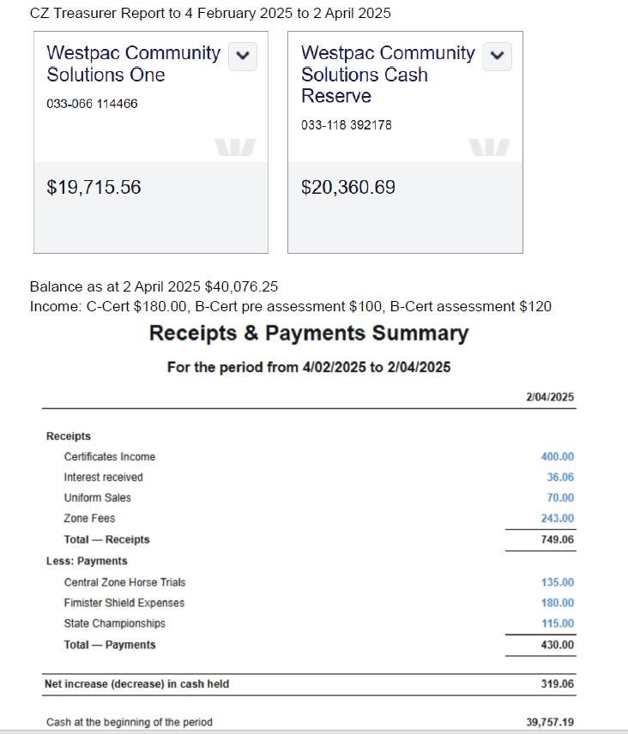

MOTION: Lisa |  |  |  |  | MOVED: |  | sECONDED:
Treasurer’s Report as tabled be noted and accepted. |  |  |  |  | Lisa |  | Niree

ITEM 3 |  |  | ZONE REPRESENTATIVE’S REPORT – Jo-anna Brennan  E-mail: jo.anna.brennan80@gmail.com
Central Zone Representative Report
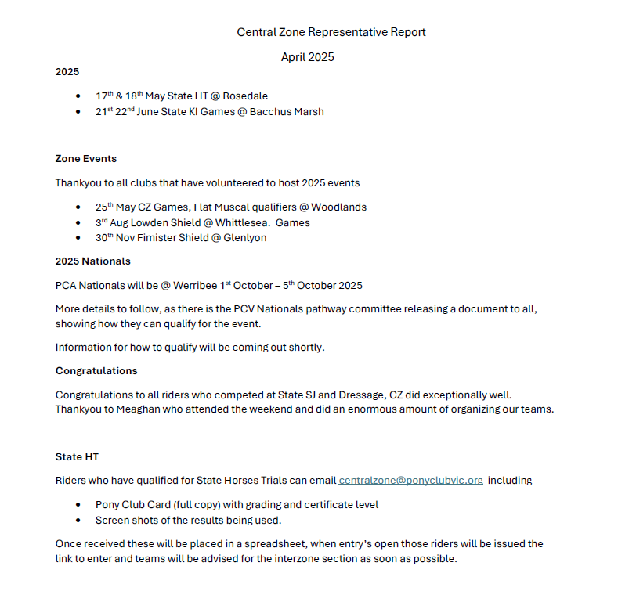
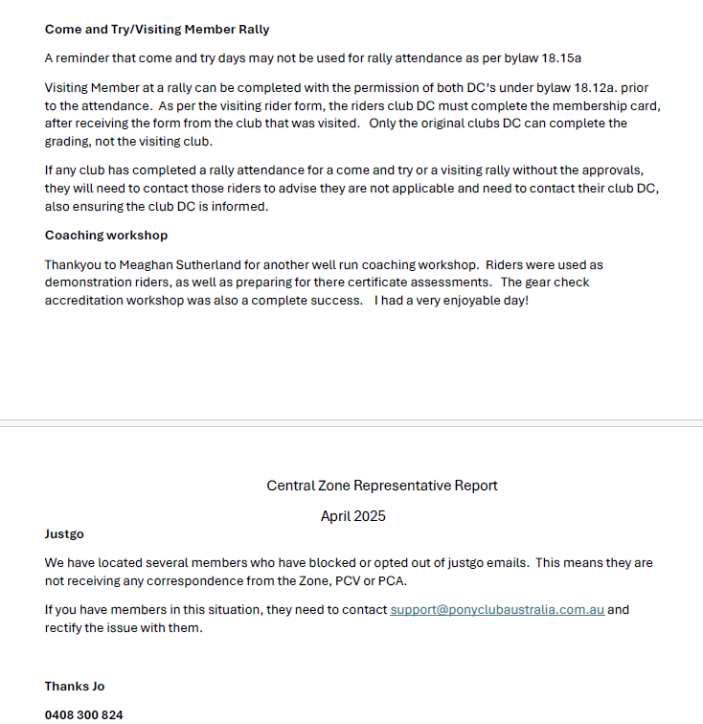

 | ITEM 4 | ZONE CHIEF INSTRUCTOR REPORT – Meaghan Sutherland  E-mail: centralzone.ci@gmail.com
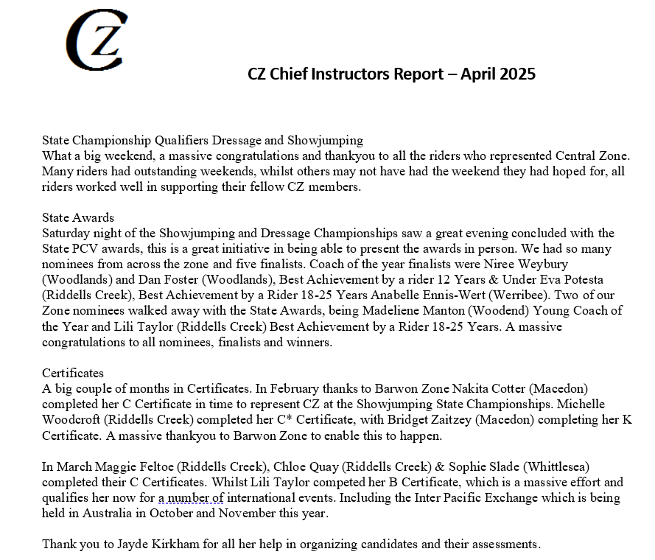

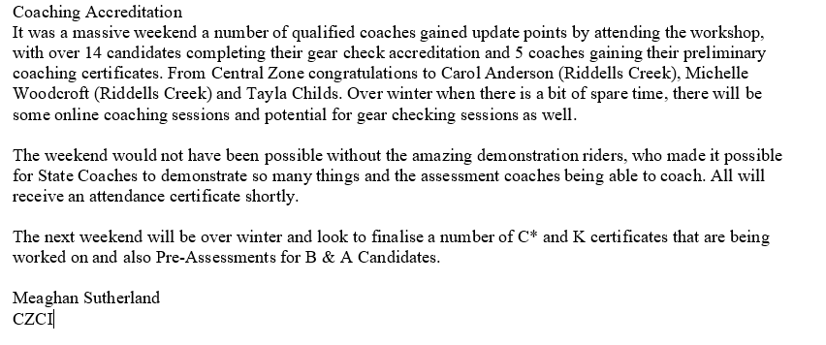

 | item 5 |  |  | ZONE EXAMINING SECRETARY – Jayde Kirkham  E: Jayde.kirkham6@gmail.com PH: 0409002164
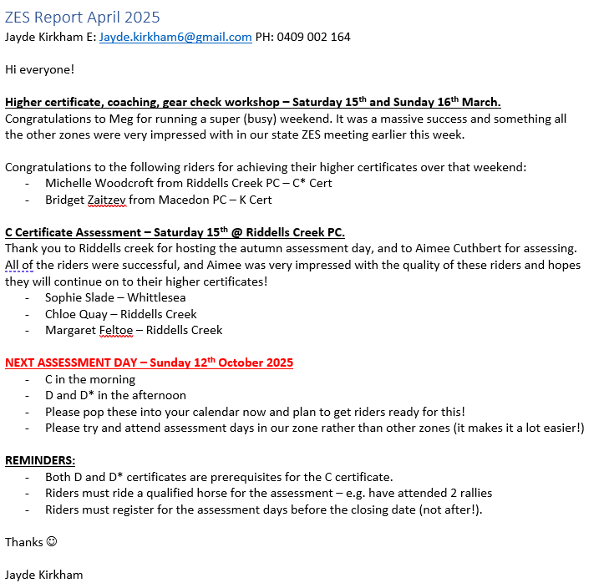

Lilly taylor b
Side note ~can you please encoureage rides to attend c certs in our zone.
Works a lot easier.
Some circumanstances it may not work but try to plan around the 2 in CZ

- MEG ~ HIGHER CERT C/C*/K have to be logged by Jk on JUST GO. Hard to keep track of outside the zone.
- Zones mostly the same but riders have jumped zones and have failed.
Williamstown to host march 2025
RTT Kilmore offered RTT
And PCV looking at werribee racecourse

ITEM 6 |  | Niree Weybury TO FOLLOW
ITEM 7 | GENERAL BUSINESS WITH NOTICE

item 8 | GENERAL BUSINESS WITHOUT NOTICE
- PAM FINDON. Zone assistants update? Still need to register. Are clubs still getting visits? Meaghan to follow up with pam.
- Lisa BROOK. Recent event at CZ. Gear check.Approved polo tops to be work under wollen jumpers. Jo advised Uniform section states shirt not polo. Jo to follow up with gear committee.
- Lisa BROOK. Recent zone event volunteer payment required. Parent helped 3 children riding did volunteer but did not get refunded. Katrina advised that was Gisborne. Was advertised and advised cash on the day, club also did advise they would refund the parent ~ who has not followed up with the Gisborne club. Katrina advised they do it 2 ways ~ cash with PC, refund with EA. It’s a huge task to ask ES to do. Aimee advised it can be done by the clu. Lisa Brook no jobs left for refund for roles ~ Katrina advised there was a job available and should have gone to the club. Lisa advised it was a club issue and was trying to bring it up to the zone. Lisa wants a procedure to be put across as a zone issue and and something in place. Maddie to agree with NW but it needs to be discussed further at a exec level.
Zone exec to come back next meeting with a guide on how this works.
- Leonie L calendar updated . melton running a show in AUGUST. Not yet on the website. Can clubs please check the calender so an updated calendar can go up. Davina RC dressage day. 13th July. Clubs needs to ensure events not on the same day. 3 events in the zone within 30 minutes. Whittlsea should be Sunday 27TH July.
- Teri Macedon. Wants to know how rider gets zone funding. Jo advised the form was sent out and is on zone website. Congrats to CZ riders that went to china
- Maddie did the CHINA EXCHANGE 2 KIDS from vic. Central and Macedon. Went to Pony Camp and our riders did games demo. Coaching riders and translaters had to translet ! Was costly but once in a life time oppurtiing , did sightseeing. Went to more stables and another comp venie. Sponsored by PORCHES. GAMES 1/2/3 AUS, 50CMS 1/2/3 60 1/2/4. Clara outstanding and it was fab time. If anyone wants to speak to Maddie about coaching or riding ,reach out. China is very different and a culture shock bt was fab.
- Nw Advised 1 trip with PCA coaching has opened the door for lots of more expreriencs.
- Sharon woodlands on the local paper did an article, and will share and pin to the zone page. Hopefulling another published story next week.
- Katrina GEAR CHECK ~ great attendance . re itteratue to clubs coaching and gear check accrediations days. MS Coach requirements are a lot different to original forms , and gear check accred is towards the end of the year for the rold out date. Coaches get access to dates on coach accrediations. 1 persone should attend child safe practice dates.
- NW advised gfm at woodlands. Compsotsite teams Contact NW. Can go to state if team makes it. And dont forget assisted riders too.

Meeting Closed: 9.09 pm

Next meeting: Thursday June 5th 2025

