Central Zone of Pony Clubs Inc.

General Meeting of Central Zone on Thursday 5TH June 2025
VIA ZOOM

Meeting Opened: 8.04 PM
 | Zone Meetings for 2025
 | Thursday 6Th February at New Gisborne Children’s Hall |  |  | Thursday 7th August 2025 online
 | Thursday 3rd April 2025 online |  |  | AGM & Zone Meeting: Thursday 9th October 2025 New Gisborne Hall
 | Thursday 5th June 2025 online |  |  | Thursday 4th December 2025 New Gisborne Children’s Hall
Central Zone Executive
Zone President: Niree Weybury (Woodlands)
Zone Vice President: Katrina McDougall (Gisborne)
Zone Vice President: Madeline Manton (Woodend) APOL
Zone Secretary: Aimee Cuthbert (Werribee)
Zone Treasurer: Lisa Kennedy (Kyneton)
Zone Representative: Jo-anna Brennan (Woodlands)
Zone Exam Secretary: Jayde Kirkham (Macedon)
Zone Chief Instructor: Meaghan Sutherland (Riddells Creek)

Minutes: Aimee Cuthbert
Denotes Action Items.
Zone Delegates Present:
Member Club | Represented by: |  | Member Club | Represented by
Broadford |  |  | Macedon | Jayde Kirkham  Olivia Greenwood  Teri Kirkham
Bullengarook | Lisa Commadeur APOL |  | Melton
Findon | Pam Kalms  Chaminda Fernando  APOL |  | Riddells Creek | Meaghan Sutherland
Glenlyon | Sarah Klas  Kris |  | Werribee | Aimee Cuthbert  Wayne Cuthbert
Gisborne | Katrina McDougall  Danielle Craig  Leonie Lang  Cara |  | Whittlesea | Jess Harris
Heathcote |  |  | Williamstown | Trish Murphy
Kilmore | Tanya Christie APOL |  | Woodend | Madeline Manton APOL
Kyneton | Lisa Kennedy  Cassandra Waters |  | Woodlands | Niree Weybury  Jo-anna Brennan
Lancefield | Emma Altas  Kristy McCarter |  | CZ ZES | Jayde Kirkham

Clubs not represented:

 |  |  | CONFIRMATION OF PREVIOUS MINUTES
Minutes of PREVIOUS MEETING as a true and accurate record as amended.

Amended to be made last minutes.

 |  |  |  |  |  | Moved: |  | Seconded:
 |  |  | BUSINESS ARISING FROM PREVIOUS MINUTES
 | Updated April minutes – Added PAM KALMS From Findon, and Olivia Greenwood
 | p
 | ITEM 1 |  | CORRESPONDENCE
Inwards:
Meaghan Sutherland Travel Form State HT
Tanya Christie, Kilmore Apology
Lisa Commaduer, Bullengarook apology
Lisa K ~ Macedon PC CZ Games and Flat entries not received
Olivia Greenwood ~ July 8 ride to time clinic at glenlyon
ASCOT SADDLERY Sponsored riders in the Zone

Dear Meg and the Central Zone Committee,

Ascot Saddlery Saddleworld is looking to support the upcoming generation of riders in the regions around Melbourne with the establishment of a network of young Team Ascot riders. We are asking each pony club in the Central Zone to nominate one rider in their club to be a member of Team Ascot for the next 12 months.

The chosen member would enjoy the following benefits of being a member of team Ascot:
- Ascot Saddlery Team Ascot kit of branded cap, T-shirt and saddle pad
- A Team Ascot discount of 15% for all purchases from Ascot Saddlery
- Ongoing profiling of their pony/horse related activities on Ascot Saddlery’s social media channels

The chosen rider does not need to be the best rider or the most competitive in the club or their grade, however, we’d ideally like them to be chosen for the following attributes.

- Aged between 12 and 18.
- Joins in with a positive attitude to the activities offered by their club
- A willingness to help other members within the club, be they older or younger
- Demonstrates responsibility, love and care for their pony at all times

The chosen rider, or rider’s parents, would be asked to tag Ascot Saddlery in on any social media post that features the rider’s equine related activities, be it competitions, club rallies, training days, trail rides, feeding time, tacking up, grooming or just mucking about with their pony.

If this is of interest to the clubs in Central Zone could this message be forwarded so they can send me the details of their nominated rider so that we can send the kit to them. I am very happy to answer any questions that the clubs or nominated riders may have if they wish to contact me directly.

Ascot Saddlery is also looking to sponsor a competition for every club in the Central Zone so if each club could let me know an event in the next 12 months that they would like some gift voucher prizes for that’d be great.

Kind Regards,

Catherine Harris
Ascot Saddlery
(03) 9376 5444

Outwards:
Responding to above

 | MOTION: |  |  |  | MOVED: |  | sECONDED:
 | Correspondence as tabled be noted and accepted.
 | ITEM 1 |  | BUSINESS ARISING FROM CORRESPONDENCE
ITEM 2 |  | TREASURER’S REPORT – Presented by Lisa Kennedy
inc
As tabled See Appendix 1
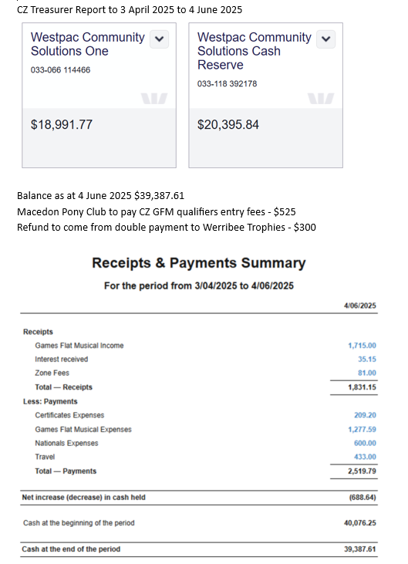

MOTION: Lisa |  |  |  |  | MOVED: |  | sECONDED:
Treasurer’s Report as tabled be noted and accepted. |  |  |  |  | Lisa |  | Niree

ITEM 3 |  |  | ZONE REPRESENTATIVE’S REPORT – Jo-anna Brennan  E-mail: jo.anna.brennan80@gmail.com
Central Zone Representative Report

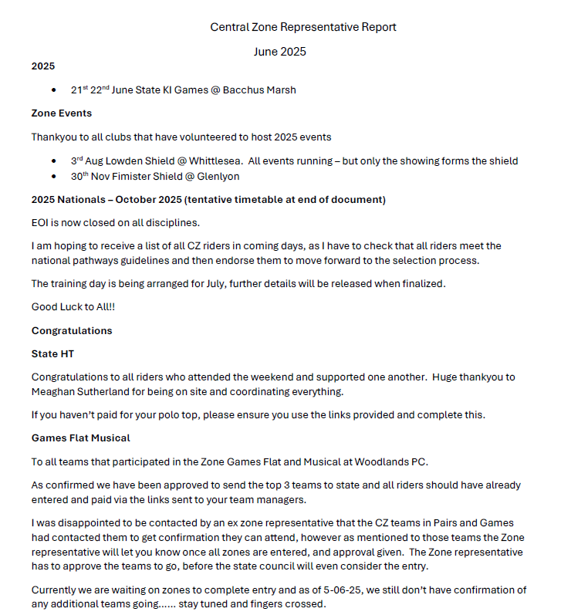
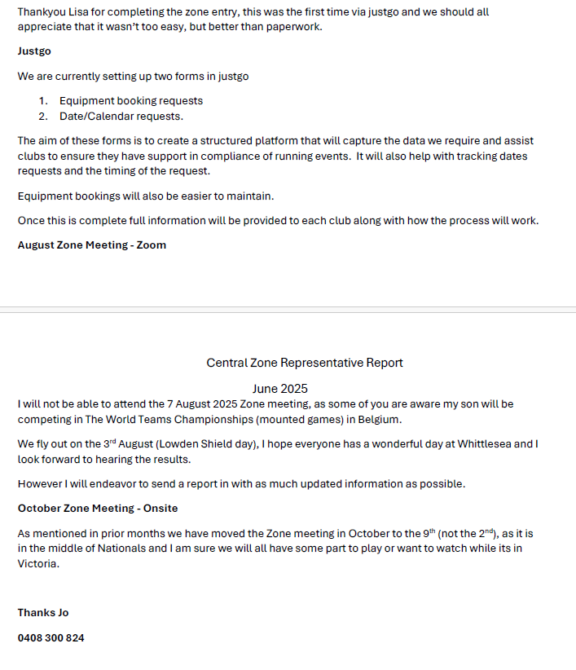

 | ITEM 4 | ZONE CHIEF INSTRUCTOR REPORT – Meaghan Sutherland  E-mail: centralzone.ci@gmail.com  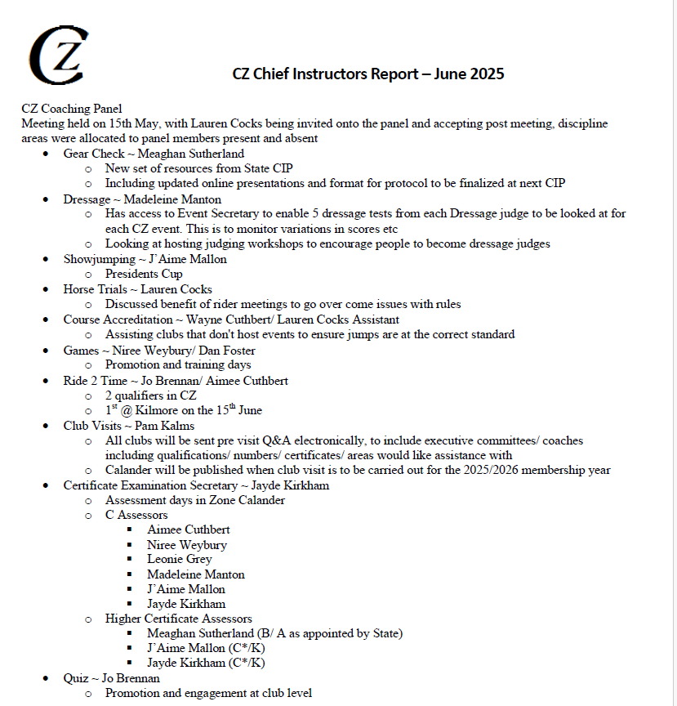  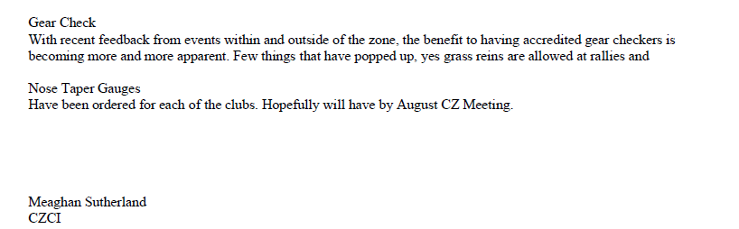
 | item 5 |  |  | ZONE EXAMINING SECRETARY – Jayde Kirkham  E: Jayde.kirkham6@gmail.com PH: 0409002164
One C certificate rider has passed in our Zone, Ben Hamilton from Woodlands.
Next C cert date is in Spring, will go ahead as normal.
Any one that has riders that have C cert assessment, please add for this date and support our Zone, rather then go to another Zone.

ITEM 6 |  | PRESIDENT’S REPORT ~ Niree Weybery  E: bernwey1@bigpond.com ph: 0408559915
Multiple people currently doing lots of Zone and State Clincis, Workshops and training at the moment, I highly recommend you get your kids involved.
Jo had a warm up Quiz last Monday , and the QUIZ Online is a lot of fun and anyone can enter. The State online quiz will be run on the 16th and 30th June.We want Central zone to do well, so make sure to get on it.
There is also a TET comp coming to Gisborne PC. TET is not a well exposed around zone, and GPC is hosting this on June 29th. Get riders exposed in other disciplines apart from the 3 in the Olypmics.
I am reining champion on the quiz ~ so get on and beat me this year!
Thankyou to everyone for their hard work! Meg is running rings around this zone as ZCI role, and Jayde also. You guys are amazing.
And congrats to all the Clubs going to Kay Irving Flat Musical Games, its going to be lots of fun!
item 8 | GENERAL BUSINESS WITHOUT NOTICE
- October Presidents Cup is the same date as the C/D/D* Certificate day. Any riders doing the Presidents cup and needing to do the C Cert, the date will be reviewed.
- Williamstown questioned life Membership, please refer to below from PCV Bylaws.
Meg from RCPC will send Trish some guidelines also.

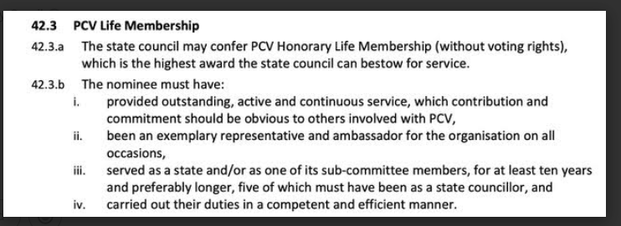
- Kristie, was after a Lowden shield program. Niree advised the flier is being revamped and will be available to clubs shortly. There are set classes but ages for the classes will not be defined until after close of entries. Jumping will be back this year as Whittlesea has the room for it. Games also included. Jumping and Games will not go towards the Hi Point, but riders will still get ribbons for these sections. Lowden shield fee covers for all sections of the day.
Chasing with Whittlsea if there is a facilty fee, and Glenlyon have the Russel Manton shield for the Lowden.

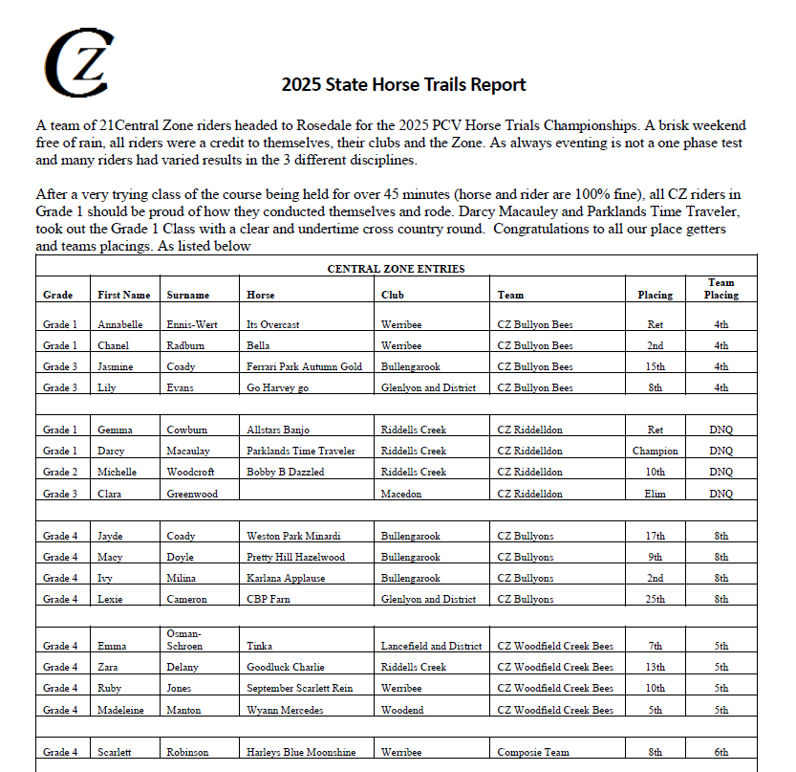
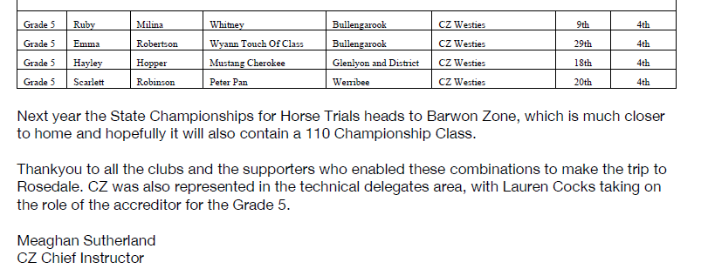

The STATE HT was discussed.
- Niree acknowledged Darcy M and his great Grade 1 riding.
- The Grade 1 riders at the event were also given a shout out due to the tough issues on the day. The course was held up,and riders were sent off the course and rugged horses as they were off the course for over an an hour. An Air Ambulance was called for a rider who fell, went to hospital for a few days.
- Wayne advised the weekend was also a bit annoying that G4 & G5 finished by 11am, and when he left at 4 pm ~ presentations were still not done. There were no CZ photos of our teams , so Maddie M filled in for everyone. There needs to be some thought and common sense about waiting all day for presentations. Meaghan advised it was also disappointing for the sponsors and none of the sponsors have any photos. Wayne left at 4 ~ CC should have been finished at 1.30 and Grade 3 Was still going when we left. There was 2 amulance calls, and it was bad luck, but going forward it would hope this is rectified.
Ride To Time vs Pony Racing
- Aimee asked about RIDE TO TIME vs PONY RACING.
- Ride to Time is Riding at a given speed
- Pony Racing is the fastest on the racetrack ~ first across the line
Unifmorms
- Questioned polo tops under jumpers ~ confirmed this was in the PCA Gear rules and they cant
Leonie ~ Calender
- Updated calender now on the website and a couple of additions are on. RCPC have a new Showjumping date, and some eventing clinics. Clinic practices will go on the calendar also.
Jess ~ First aid & paramedics
- Been getting quotes for a showjumping comp, its nearly $2000 to hire from a company. Will work internally to organise a paramedic and having a back up first aid.
- Questiond the FF for the Lowden Shield, it needs to be passed onto the venue but will be collected with the entries
- Email will be sent to the club about how to set up for the shield
- Jo also advised in regards to the back up first aid ~ if some one is on back up first aid ~ this is their only role for the day. Not 10 other jobs Also. First aid means first aid, not coffee runs and canteen
- Clubs also should have a first aid area
Vale:
- Joyce Williams recently passed away. Joyce had a lot to do with her Club and the zone during her time in Pony Club.
- Also Lola Forsth , zone life member, turns 100 this year.

Meeting Closed: 8.53 pm

Next meeting: Thursday August 7th.

