Central Zone of Pony Clubs Inc.

General Meeting of Central Zone on Thursday 5TH Februrary 2026
VIA ZOOM

Meeting Opened: 8.10 PM
 | Zone Meetings for 2025
 | Thursday 6Th February at New Gisborne Children’s Hall |  |  | Thursday 6th August 2026 online
 | Thursday 26Th March online |  |  | AGM & Zone Meeting: Thursday 1st October 2026 New Gisborne Hall
 | Thursday 4th June 2026 online |  |  | Thursday 3rd December 2026 New Gisborne Children’s Hall
Central Zone Executive
Zone President: Niree Weybury (Woodlands)
Zone Vice President: Katrina McDougall (Gisborne)
Zone Vice President: Madeline Manton (Woodend) APOL
Zone Secretary: Aimee Cuthbert (Werribee)
Zone Treasurer: Lisa Kennedy (Kyneton)
Zone Representative: Jo-anna Brennan (Woodlands)
Zone Exam Secretary: Jayde Kirkham (Macedon)
Zone Chief Instructor: Meaghan Sutherland (Riddells Creek)

Minutes: Aimee Cuthbert
Denotes Action Items.
Zone Delegates Present:
Member Club | Represented by: |  | Member Club | Represented by
Broadford | IN RECESS |  | Macedon | Jayde Kirkham
Bullengarook |  |  | Melton
Findon | Pam Kalms  Ines Santos Mattos |  | Riddells Creek | Meaghan Sutherland  Carol
Glenlyon | Sarah Klas  Eva |  | Werribee | Aimee Cuthbert  Wayne Cuthbert
Gisborne | Katrina McDougall  Danielle Craig  Cara |  | Whittlesea | Naomie Slade
Heathcote |  |  | Williamstown | Emmy lou
Kilmore | Tayna Christie APOL |  | Woodend | Madeline Manton APOL
Kyneton | Lisa Kennedy  Cassandra Waters |  | Woodlands | Niree Weybury  Jo-anna Brennan  Dan Foster
Lancefield | Emma Altas  Kristy McCarter |  | CZ ZES | Jayde Kirkham

Clubs not represented: Bullengarook, Heathcote, Melton.
Apologies: Tayna Christie, Madeline Manton

 |  |  | CONFIRMATION OF PREVIOUS MINUTES
Minutes of PREVIOUS MEETING as a true and accurate record as amended.

Amended to be made last minutes.

 |  |  |  |  |  | Moved: |  | Seconded:
 |  |  | BUSINESCS ARISING FROM PREVIOUS MINUTES
 | p
 | ITEM 1 |  | CORRESPONDENCE
Inwards:
Riders PCA Nationals Funding 2025
Gisborne PC Fimister Shield 2026
Presidents Cup ribbons
Glenlyon PC ~ radio hire
State Horse Trials Qualification 2026
QuickBooks Invoice
Qualified and Reserve Central Zone Riders for Showjumping and Dressage State Championship

Outwards:
Gisborne PC Fimister Shield 2026
Presidents Cup ribbons
Glenlyon PC ~ radio hire

 | MOTION: |  |  |  | MOVED: |  | sECONDED:
 | Correspondence as tabled be noted and accepted. Deferred to next meeting.
 | ITEM 1 |  | BUSINESS ARISING FROM CORRESPONDENCE
ITEM 2 |  | TREASURER’S REPORT – Presented by Lisa Kennedy
inc
As tabled See Appendix 1

MOTION: Lisa |  |  |  |  | MOVED: |  | sECONDED:
Treasurer’s Report as tabled be noted and accepted. |  |  |  |  | Joanna B |  | Niree

ITEM 3 |  |  | ZONE REPRESENTATIVE’S REPORT – Jo-anna Brennan  E-mail: jo.anna.brennan80@gmail.com
Central Zone Representative Report

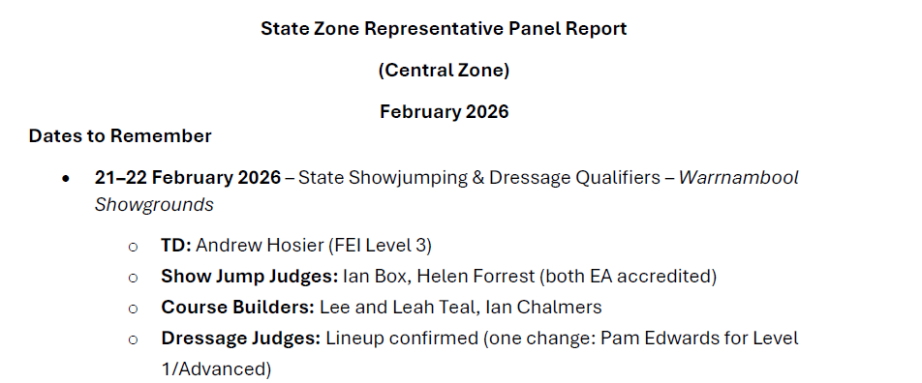

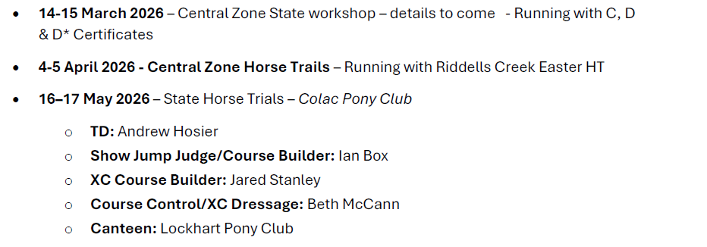
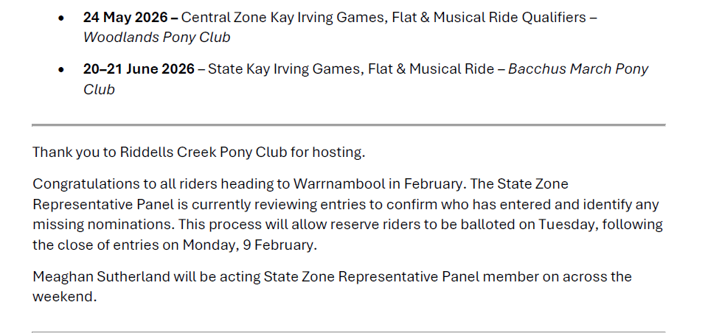

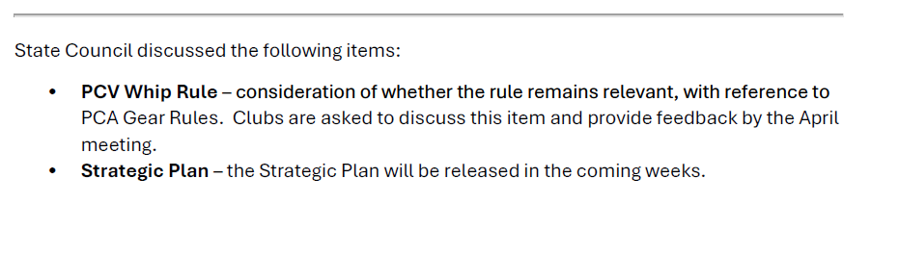

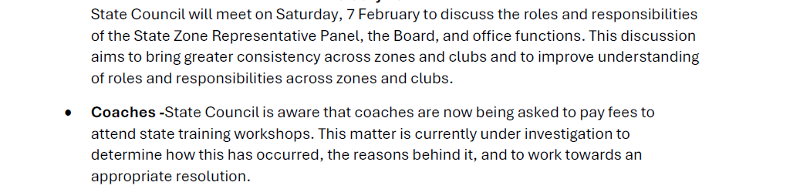

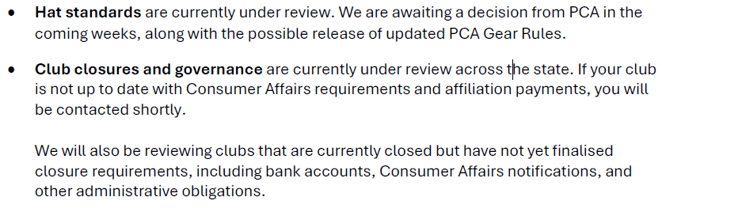

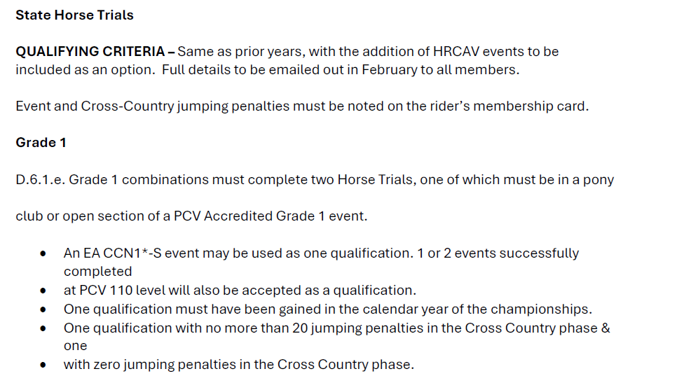

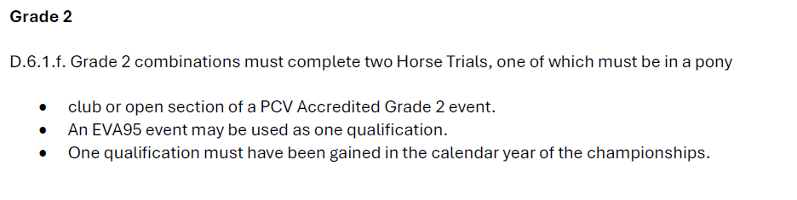

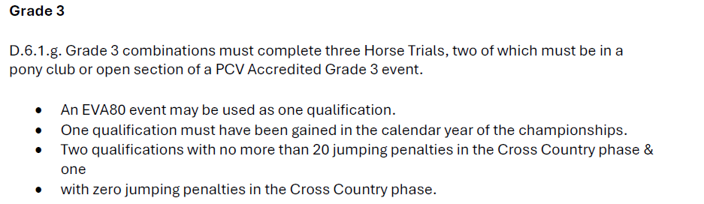

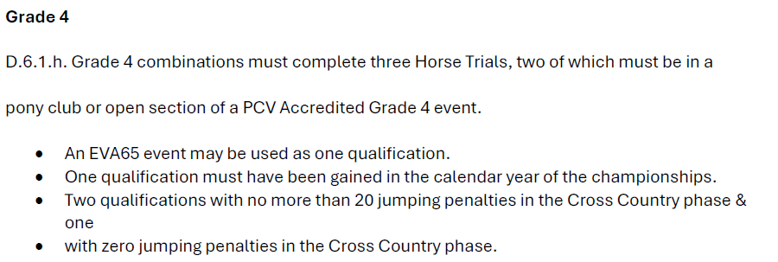
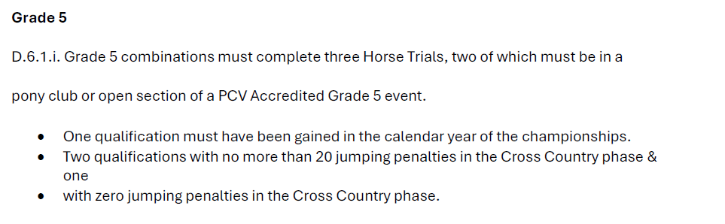

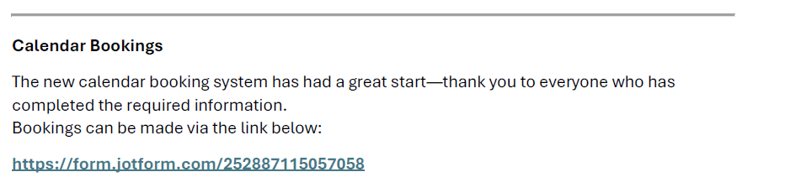

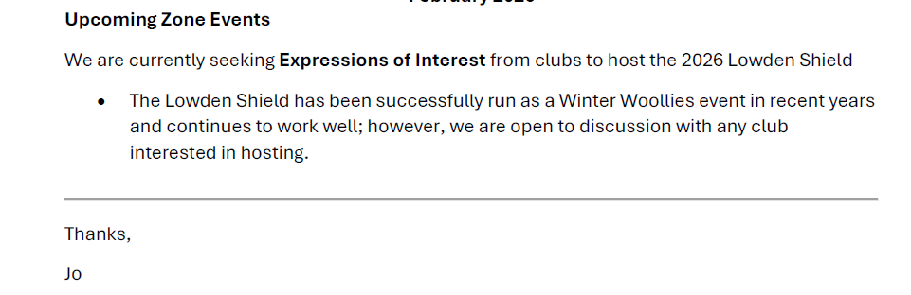

 | ITEM 4 | ZONE CHIEF INSTRUCTOR REPORT – Meaghan Sutherland  E-mail: centralzone.ci@gmail.com
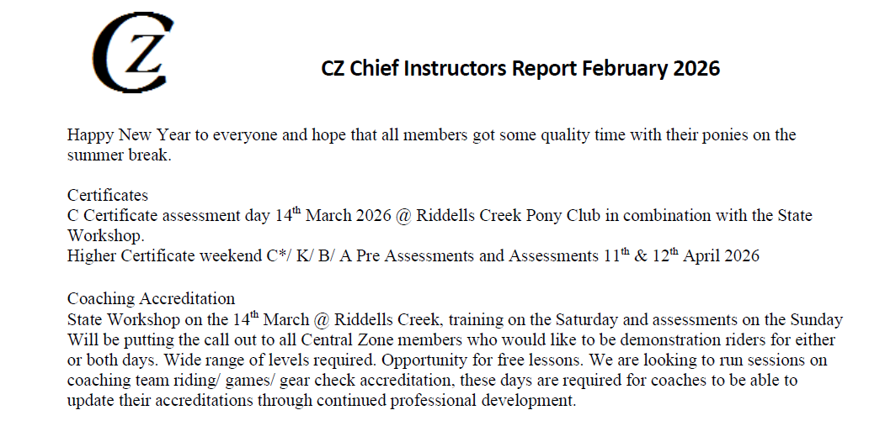

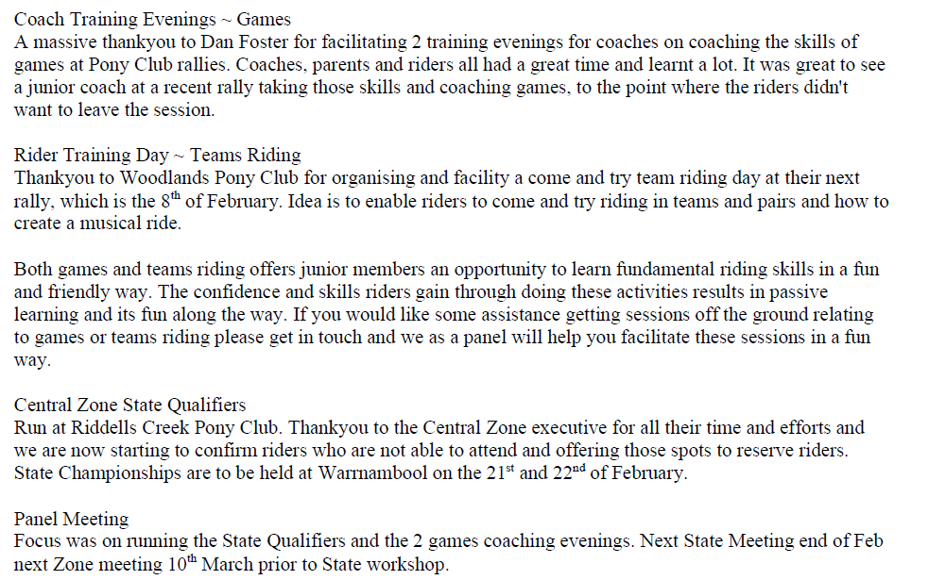

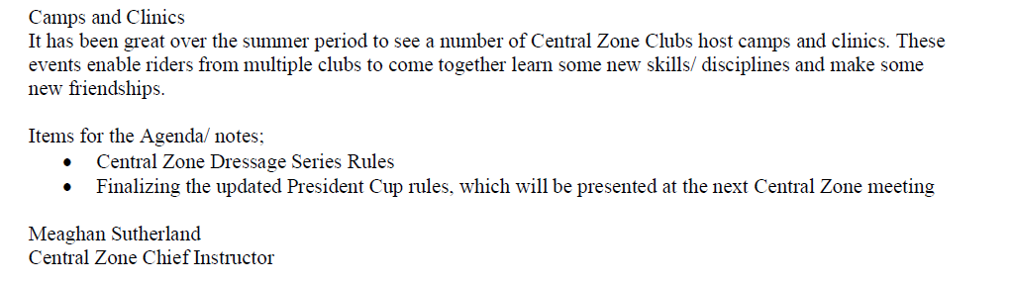

 | item 5 |  |  | ZONE EXAMINING SECRETARY – Jayde Kirkham  E: Jayde.kirkham6@gmail.com PH: 0409002164
March D D* & C certificates bookings are now open. Date is 14th March at Riddells Creek PC Grounds. A reminder that it is full is full uniform for assessment days and all PCV Worksbooks are to be completed prior to the ridden assessment.
Make sure to check riders ages at start at year to see if they will need their C certificate during that year for State Events.

ITEM 6 |  | PRESIDENT – Niree Weybury  E: bernwey1@bigpond.com PH: 0408 559 915
Thanks to RCPC for hosting the a wonderful event for the Zone Dressage and Showjumping Championships, and congratulations to all riders that attended.

This weekend, there will be a Flat Team of 4 training day at Woodlands PC grounds. Riders can attend on their own,or in a group, it will just be a training day to get them started, and help parents also. Thisis a day to help everyone with the how to read the tests, and we hope to encourage lots of kids across the State to do the Flat Team events.
Other zones have been tapping into Central for this event, which is encouraging to see.

Nationals 2025 was hosted by Victoria, and the Riders Rider funding bbq cut of the fundraising is on the way.

On the Zone Coaching Panel, there are coaches that specialize in different areas. I specialize in Games.

There is a pathway for riders wanting to do National Mounted Games, and that is with Clinics. There are a lot of clubs out there with talented riders, but I am not seeing them!

The pathway is the riders first need to come to a clinic, then to the 2 selection days that are held in June. At selection, riders then run off against the clock, then they are placed into the Nationals team and represent Victoria!

Nationals for Mounted Games is every, and in 2026, the host State is the Northern Territotry, and will be on borrowed horses. There are set races, and the rider will compete on 4 or 5 races on same horse, then swap horses. This will be held in September.

Next PCA Nationals is 2027, and the venue is yet TBC.

Niree Weybury
Central Zone President

ITEM 7 | GENERAL BUSINESS WITH NOTICE
- GISBORNE To host the Fimister in 2026.
Gisborne PC are happy to host the 2026 Fimister Shield. Date proposed SUN 29 NOV. Zone contribution fee $5.00. Facility fee $ 7.00 per horse. Yards will be available in addition for $10.00 per yard.

- Central Zone HT 2026 .
This is being held in conjunction with the Riddells Creek Easter Horse Trials, on the first weekend of April. Being the 1st Sunday, it will clash with Club rallies. Because it’s a Zone Event and IF it clashes with a rally, as it is a State qualifier, it can be used as attendance.

- State HT qualifier 2026
Please refer back to Jo Zone rep report
Gisborne Pony Club Motion:

Gisborne Pony Club is submitting the following motion about the optimum time article for F and G grade show jumping for tabling at the Central Zone meeting.

After a year of trialling the new article it has been observed many children are deliberately working in circles and riding at a slower pace than is safe and developmentally appropriate. As such children are losing forward motion in front of jumps and ponies stopping instead of holding a steady canter over the jumps.

In the light of this, we would like the following motion to be put to the Central Zone general meeting:
“That the PCV rules for F and G grade show jumping revert to the FEI rules as for the other grades, but with no penalty for the trotting/slow pony.”

As the ethos of pony club is to use a grading system it is recommended that DCs grade appropriately to ensure riders going dangerously fast are educated rather than altering the premise of teaching junior riders for show jumping competitions.

If this motion is carried, it should be forwarded to the PCV Zone Representatives Council as correspondence.

In the event that this motion fails, please table this second motion:

“That the articles for F and G grade show jumping be replaced by an Equitation style event. This will not be judged using score sheets but will be based on the judge’s opinion.”

An equitation style event is like “hunter jumping” which is an established discipline around the world such as the USA where riders process from “hunters” to “jumpers” Events.
If this motion is carried, the proviso of considering it if motion 1 fails could be included in the correspondence to PCV.

Kind regards,
Danielle Craige

Gisborne Pony Club

Allocated delegate needs to be at the March meeting to vote.

item 8 | GENERAL BUSINESS WITHOUT NOTICE
- April meeting ~ moved to THURSDAY 26TH MARCH. IN PERSON (Updated ~ now on zoom)
- Gisborne ~ regarding the CZ dressage series rules. Disccused a minimum 5 rounds of the event, have enough events to go through the year. Rider with the top scores then goes to state Dressagte. Dressage team of 3.
Ask to the clubs to confirm that they are wanting to host the dressage series in with their dressage events.
Need to name the series CZ dressage series.
Showjumping : President cup revised rules also to be sent out to all Club also. The State SJ team of 4.
The Series winner may not be the same as the qualified rider from the series.
- Williamstown ~ about to order uniforms and clarufing the PCV logo. It is not needed for PC rallies, but is not a competition polo top.
- For riders that also compete at State Events ~ riders can wear black v neck jumpers, stock or shirt and tie.
- Wayne C.
Advised a small group are going to run HT at WPNEC this year. Dates are booked and it will be ~ 3 part series. Grade 3-6 Saturday only. June 20th. 4th July. 18th July.
- CZ events forms need to be sent on the JOT Form: https://form.jotform.com/252887115057058
- Lancfield PC ~ members going from READY TO RIDER to full member, how many rallies until they are graded? PCV Simply says 2 rallies.

Meeting Closed: 9.11 PM

Next meeting: THURSDAY MARCH 28

